CXBanking

OptiVLM CarrierWeb 10.0

User Reference Guide

**Build 4027**

**Version 10.0**

**March 2023**

Copyright and Trademark Information

If this guide is distributed with software that includes an end-user agreement, this guide, as well as the software described in it, is furnished under license and may be used or copied only in accordance with the terms of such license. Except as permitted by any such license, no part of this guide may be reproduced, stored in a retrieval system, or transmitted, in any form or by any means, electronic, mechanical, recording, or otherwise, without the prior written permission of NCR Incorporated. Please note that the content in this guide is protected under copyright law even if it is not distributed with software that includes an end-user license agreement.

The content of this guide is furnished for informational use only, is subject to change without notice, and should not be construed as a commitment by NCR Incorporated. NCR Incorporated assumes no responsibility or liability for any errors or inaccuracies that may appear in the informational content contained in this guide.

OptiCash, OptiNet, OptiVault, OptiCashMI, OptiVLM, OptimizeCF, OptiSuite, OptiRecon, and OptiBridge are trademarks of NCR International Inc.

Adobe Acrobat Reader is a registered trademark of Adobe Systems Incorporated. Microsoft, Windows, and Windows Vista, Internet Explorer (IE) are either registered trademarks or trademarks of Microsoft Corporation in the United States and/or other countries. Solaris is a Trademark or registered trademark of Sun Microsystems, Inc. in the United States and other countries. Oracle is a trademark of Oracle in the United States and other countries. WebSphere is a trademark of IBM in the United States and other countries. UNIX is a trademark in the United States and other countries, licensed exclusively through X/Open Company, Ltd. All other trademarks are the property of their respective owners.

Copyright © NCR. All Rights Reserved

Revision Record

|  |  |  |
| --- | --- | --- |
| Date | Page No. | Description of Change |
| 10 March 2023 | All | Formatting Changes |
|  |  |  |
|  |  |  |

Contents

Copyright and Trademark Information 2

Revision Record 3

Contents 4

1 INTRODUCTION TO CARRIER WEB 7

1.1 CONVENTIONS USED IN THIS HELP DOCUMENTATION 7

1.2 GETTING STARTED 8

1.2.1 SCREEN RESOLUTION 8

1.2.2 NAVIGATION TIPS 8

1.2.3 ACCESSING VAULT BALANCE 8

1.2.4 LOGGING IN 9

1.2.5 LOGGING OUT 9

1.3 INTERFACE OVERVIEW 9

1.3.1 MAIN MENU TABS 10

1.3.2 COMMON CARRIER WEB ICONS AND BUTTONS 10

1.3.3 DATE SELECTOR 11

2 DASHBOARD 13

3 EMPLOYEES 16

3.1 LIST ALL EMPLOYEES 18

3.2 IMPORT EMPLOYEES 19

4 DEPOTS 20

4.2 LIST DEPOTS 20

4.3 SHOW DEPOT 21

4.4 IMPORT VAULT HISTORY 22

5 ORDERS 23

5.1 CREATE ORDER 23

5.2 CREATE ORDERS - DENOMINATIONS 24

5.3 CREATE ORDERS - MAINTENANCE VISIT 25

5.4 LIST BY WORKFLOW 27

5.5 SHOW MANIFEST 29

5.6 SHOW ORDER 30

5.7 EDIT ORDER 32

5.8 SEARCH ORDERS 34

5.9 EXPORT ORDERS 35

5.10 IMPORT ORDER UPDATES 36

5.11 IMPORT ATM RESIDUALS 37

5.12 VIEW DISPUTES 37

5.13 INPUT DISPUTES 39

6 ROUTES 42

6.1 CREATE NEW ROUTE 42

6.2 LIST ALL ROUTES 43

6.3 ROUTE PLAN DOCUMENT 43

6.4 ROUTE PLAN AUDIT 45

6.5 CREATE/UPDATE ROUTE PLAN DETAIL 45

6.6 MANAGE TRUCKS 47

6.7 SHOW TRUCK 49

6.8 CREATE NEW TRUCK 50

6.9 MANAGE DEFAULT ROUTES 51

6.10 SHOW DEFAULT ROUTE 51

6.11 UPDATE DEFAULT ROUTE 52

7 CONTAINERS 54

7.1 IMPORT CONTAINERS 54

7.2 CREATE NEW CONTAINER 54

7.3 CONTAINER BULK CREATION 56

7.4 LIST ALL CONTAINERS 57

7.5 CONTAINER LOCATIONS 60

7.6 CONTAINER ALERTS 61

8 REPORTS 63

8.1 ROUTE PLAN SUMMARY REPORT 63

8.2 ATM RESIDUALS REPORT 64

8.3 CONTAINER ASSET REPORT 64

8.4 CONTAINER USE BY LOCATION REPORT 66

8.5 VAULT LOAD HISTORY REPORT 67

9 SETTINGS 69

9.1 WORKFLOW CONFIGURATION 69

9.2 SYSTEM SETTINGS 70

9.3 USERS 71

9.4 UPDATE USER 72

9.5 USER GROUPS 73

9.6 SHOW USER GROUP 74

9.7 CREATE OR EDIT USER GROUP 75

9.8 ORDER CUSTOM FIELDS 75

9.9 ROUTE FIELD CONFIGURATION 77

9.10 ROUTE PLAN WORKFLOW 78

9.11 VAULT LOAD CONFIGURATION 79

9.12 80

9.13 NOTIFICATION HISTORY 80

10 Mobile CarrierWeb 81

10.2 PACKAGE ORDER 81

10.3 ARRIVAL 83

10.4 DEPARTURE 86

10.5 CONTAINER STOCK 88

11 APPENDIX A: OPTITRANSPORT 91

11.1 SHORTEST PATH CALCULATION PANEL 91

# INTRODUCTION TO CARRIER WEB

OptiVLM (Vault Logistics Management) is a multi-module solution. See Table 1 *OptiVLM Modules* below. OptiVLM integrates with OptiSuite (OptiCash, OptiNet, and OptiVault) data to provide multi-user access to real-time updated information regarding currency inventory and orders as they move between financial institutions, central banks or other cash sources, and armored car networks.

TABLE 1:OPTIVLM MODULES

|  |  |
| --- | --- |
| Module | Description |
| Invoice Validation | Compares invoices related to cash transportation activities with activity records from OptiSuite. Invoice Validation searches for discrepancies in services rendered, amounts transported, and applied billing rates. |
| Carrier Web | Provides an interface for carriers (armored car vendors) to access and update order status. Carrier Web also provides branches access to information regarding authorized carrier personnel. |
| Vault Balance  | Utilizing OptiSuite activity, Vault Balance provides real-time updates for your vaults’ balances and activity. |

OptiVLM is hosted and managed by the financial institution, but the different modules may be accessible and operated by external users including the vaults and armored car vendors.

**This User Guide is concerned with the Carrier Web module. For user information relative to the Invoice Validation or the Vault Balance interfaces, please refer to the respective guides.**

|  |  |
| --- | --- |
|  | **Caution:** OptiVLM is a live application. Changes that are made in the application are permanent and can affect the operation of the system. There are limited undo capabilities for the users; therefore, be sure to consult this manual before deleting or changing system parameters. |

## CONVENTIONS USED IN THIS HELP DOCUMENTATION

The conventions used in this help documentation are shown in the table below.

TABLE 2: CONVENTIONS

|  |  |
| --- | --- |
| Convention | Use |
| Green Text | Indicates a link to the top of the current section. These links can be clicked to quickly navigate through this document. (In some cases you may need to hold the CTRL key to click the link) |
| Blue Text | Indicates a link to the different topic or section. These links can be clicked to quickly navigate through this document. (In some cases you may need to hold the CTRL key to click the link) |
| →  | The “arrow” sign indicates a menu choice. For example, "**Choose File** → **Open**" means "click the File menu, and then click Open." |
|  | Used to warn users of potential problems or to take caution when making changes to setting and parameters. |
|  | Tips or information that may be helpful in using the functionality. |

## GETTING STARTED

Carrier Web is a web-based application that automatically updates itself in real-time based upon OptiSuite activity. As currency moves among the various cashpoints (ATMs, Branches, Vaults), Carrier Web will reflect the real-time activity.

### SCREEN RESOLUTION

Because OptiVLM runs in a browser, the user may choose any valid desktop resolution, and OptiVLM will resize automatically. 1024x768 resolution and larger is recommended in order to minimize scrolling on some of the screens containing large amounts of information.

### NAVIGATION TIPS

When using OptiVLM, avoid using the Back and Forward buttons  in the browser. All navigation should occur within the application via the menu or icons thereby insuring successful processing of the OptiVLM system.

### ACCESSING VAULT BALANCE

To begin using the application, enter the required OptiVLM URL in the Browser.

|  |  |
| --- | --- |
|  | **Suggestion:** save the OptiVLM URL in the Favorites folder for easier future access. |

### LOGGING IN

Carrier Web will launch within the browser. Security is supplied via external authentication via your systems network logon. If you are not already logged in via network authentication you will be prompted for a username and password. To login, enter your Username and Password and click Login.

|  |  |
| --- | --- |
|  | **Note:**  For **External Authentication**, the Login prompt will not be displayed. Login will be automatic based on network authentication. |

### LOGGING OUT

To logout, simply close the browser or log out via external authentication method

## INTERFACE OVERVIEW

The following section will show examples of the Carrier Web interface pages and provide explanations of the functionality, purpose, or use of each page. This section is a reference when working with the application on a daily basis.

In order to keep this manual as succinct as possible, the user interface is described in detail in this section. Other chapters throughout the manual will then refer to the appropriate section of the user interface to avoid having duplicate screen images and text.

This chapter has been broken out into different sections to make it easier for readers to find the information they are seeking. The General topics are broken out by the main Tabs or functions with all associated information contained beneath those sections. The following is a summary of the information that will be covered along with hyperlinks to each topic.

* MAIN MENU TABS
* COMMON CARRIER WEB ICONS AND BUTTONS
* DATE SELECTOR

### MAIN MENU TABS

The user is able to control Carrier Web operations through the main menu tabs displayed in the picture below. After selecting the menu items, additional options are displayed, until a final menu option is reached, allowing full access to all functions.

FIGURE 1: MAIN MENU TABS

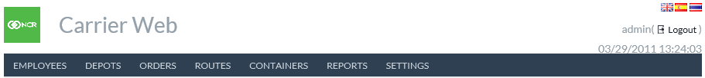

Return to: Interface Overview

TABLE 3: MAIN MENU TABS

|  |  |
| --- | --- |
| Tabs | Description |
| Employees | Accesses the controls for entering Depot/Carrier employee information. Carriers can enter descriptive information that will allow vaults and branches to insure the identity of the carrier personnel they interact with |
| Depots | Accesses listings of all associated depots and the cashpoints (ATM, Branch, and Vault) that each depot services |
| Orders | Accesses the ability to list all orders by type, upload order update files, and export orders |
| Routes | Accesses route planning and the trucks including type and capacity |
| Reports | Accesses reports of CarrierWeb activity |
| Settings | Accesses the parameters and settings associated with Carrier Web |

Return to: Interface Overview

### COMMON CARRIER WEB ICONS AND BUTTONS

Some common icons and buttons are used throughout the application with which the user should become familiar. Table 4: OptiVLM-Carrier Web Icons gives an overview of these icons and their functions.

TABLE 4: OPTIVLM-CARRIER WEB ICONS

| Icon | Description |
| --- | --- |
|  | **New Icon:** Add a new record. |
|  | **View Icon:** View a specific record. |
|  | **Update Icon:** Update a specific record. |
|  | **Delete Icon:** Delete the associated record. |
|  | **Export to CSV:** Exports screen contents to a .csv report for external analysis |
|  | Select **English** language |
|  | Select **Spanish** Language |
|  | Select **Thai** Language |
|  | **Save**: Allows changes made on screen to be permanently saved to the appropriate file |

Return to: Interface Overview

### DATE SELECTOR

In several areas of the application, it may be necessary to select or change a date for reports, orders, etc.

FIGURE 2: DATE SELECTOR

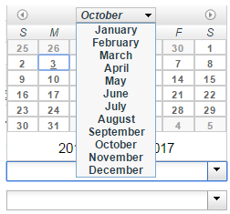

Return to: Interface Overview

TABLE 5: DATE SELECTOR DESCRIPTION

|  |  |
| --- | --- |
| Field | Description |
|  | Moves the Calendar 1 month forward or backward |
| Dates | Selects the date of the month to be searched for |
| Years | Specifies the year to be searched |

# DASHBOARD

The Dashboard page that is the landing page when logging into the app and can be accessed by clicking on the logo on the top left corner of the page.

FIGURE 3: DASHBOARD SCREEN

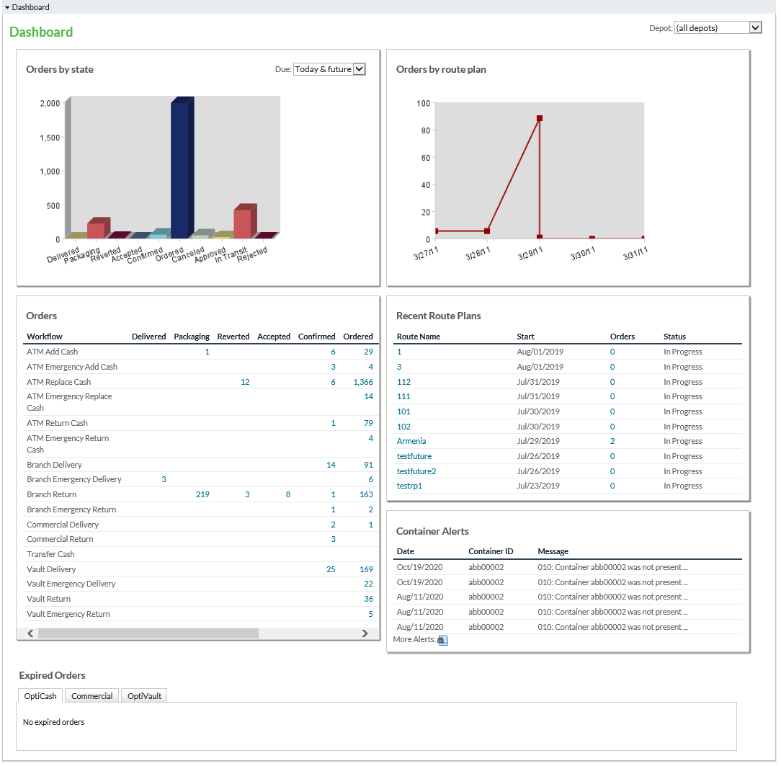

Return to: Dashboard

##### TABLE 6:DASHBOARD SCREEN

|  |  |
| --- | --- |
| Field | Description |
| Orders Bar Chart | It shows how many orders are in a given state. It does so by counting all orders visible to this user in each state. The states are “view states” defined in CarrierWeb, i.e. the states that this user is allowed to see. |
| Orders Table | Shows order amounts in each workflow and state. All workflows visible to this user will be shown. Clicking an amount takes the user to the Order Search page with the relevant orders listed |
| Route Plans Line Chart | Shows number of orders delivered in the last 7 days. The Y-axis shows the number of orders. This chart aggregates all route plans for a given date. |
| Route Plans Table | Shows the list of last 10 route plans sorted by date. For each route plan we show the number of orders. Clicking the route plan name, takes the user to the route plan view page. Clicking the number of orders takes the user to the Order Search screen with those orders shown. |
| Container Alerts | Lists the most recent container alerts, with link to view more alerts if desired. |
| Expired Orders | Shows the OptiCash, Commerical and OptiVault orders that are currently in the expired state, which each type of order in their own tab. Orders can be viewed by clicking on the view icon in each order row. |

Return to: Dashboard

# EMPLOYEES

CarrierWeb allows descriptive information about carrier employees to be saved in the software and then accessed by Vaults and Branches serviced by the carrier. This adds an additional security measure in that carrier clients can verify the identity of the armored car staff.

Information including a photo, eye color, hair color, height, weight, and badge ID may be included in each Employee Profile.

FIGURE 4: CREATE NEW EMPLOYEE

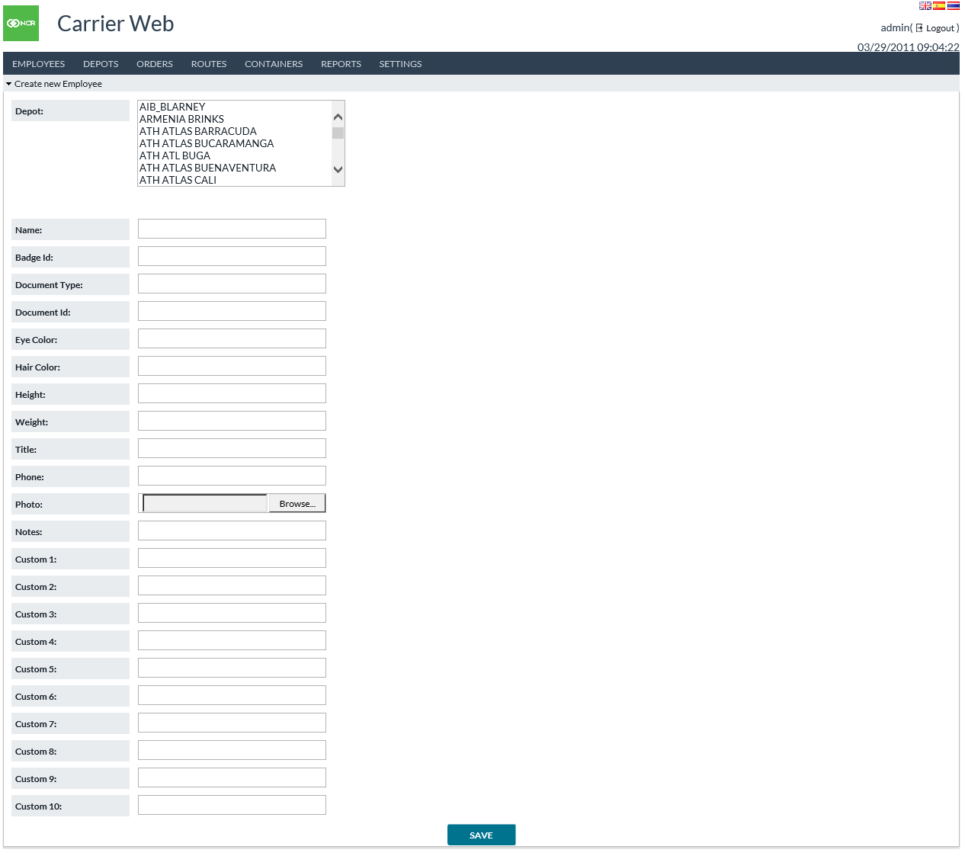

TABLE 7:CREATE NEW EMPLOYEE FIELD DESCRIPTIONS

|  |  |
| --- | --- |
| Field | Description |
| **Depot** | CarrierWeb attaches each employee to one or more Depots. When setting up Employees, Administrators select the corresponding Depots from the menu. |
| **Name** | Employee’s Name |
| **Badge ID** | Badge identification number for each employee |
| **Document Type** | Employee’s identification document (National ID, Passport, Driver’s License, et al) |
| **Document ID** | Unique identification number of the employee’s ID |
| **Eye Color** | Employee’s Eye Color |
| **Hair Color** | Employee’s Hair Color |
| **Height** | Employee’s Height. Since it is a text field, it can be metric or English measurement |
| **Weight** | Employee’s Weight. Text field like Height and can be Metric or English measurement |
| **Title** | Employee’s Title |
| **Phone** | Employee’s contact telephone number |
| **Photo** | Upload a Passport/Identification photo to CarrierWeb so that other users can use as positive identification of carrier personnel. |
| **Notes** | Miscellaneous comments to further describe or define each employee. Perhaps it is a distinguishing mark such as a visible tattoo or other physical feature |
| **Custom 1-10** | CarrierWeb allows 10 available Custom fields for usage as user may require |

Return to: Employees

## LIST ALL EMPLOYEES

List All Employees provides the same detail as defined in the Create New Employee Field Descriptions table and shows many employees at once.

Icons on the right side of list provide detailed view, Edit, and Delete functions respectively.

##### Create New Employee icon in the bottom left hand of the table will take users to the Create New Employee input screen.

##### FIGURE 5: LIST ALL EMPLOYEES SCREEN

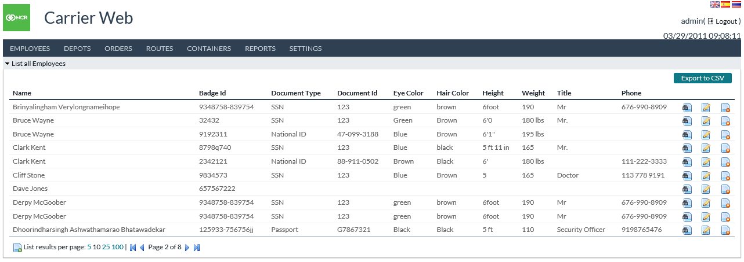

Return to: Employees

## IMPORT EMPLOYEES

###### Import allows users to upload a formatted file of employee information so that new employees and/or updates can be performed en masse.

###### FIGURE 6: IMPORT EMPLOYEES SCREEN

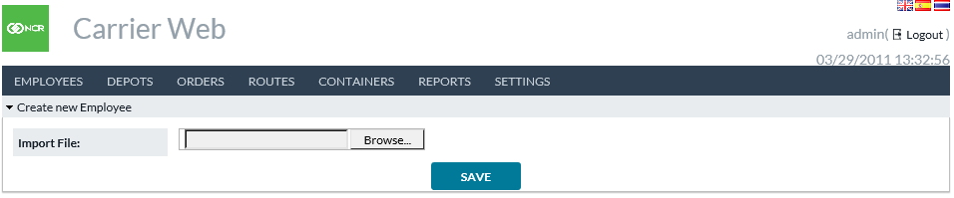

Return to: Employees

# DEPOTS

Depots is a gateway menu to the List All Depots and Show Depot screens. Depots are unique cash distribution locations that are usually various sites of one company or corporation contracted to provided secured cash delivery service to financial institutions.

## LIST DEPOTS

List Depots provides a listing of accessible depot locations utilizing Carrier Web

##### FIGURE 7: LIST DEPOTS SCREEN

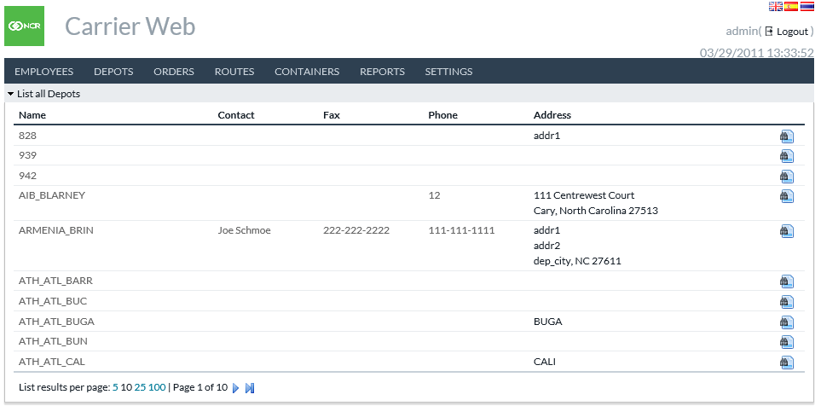

TABLE 8: DEPOTS FIELD DEFINITIONS

|  |  |
| --- | --- |
| Field | Description |
| **Name** | Name of the particular Depot |
| **Contact** | Contact person at Depot |
| **Fax** | Fax number for Depot |
| **Phone** | Telephone number for Depot |
| **Address** | Physical Address of Depot |
|  | The icon allows users to view details of the selected Depot. |

Return to: Depots

## SHOW DEPOT

By clicking on the Show Depot icon on the List All Depots screen the user can navigate to the Show Depot screen. Show Depot lists all the fields from the List screen, and it also shows the OptiSuite cashpoints serviced by the depot.

FIGURE 8: SHOW DEPOT SCREEN

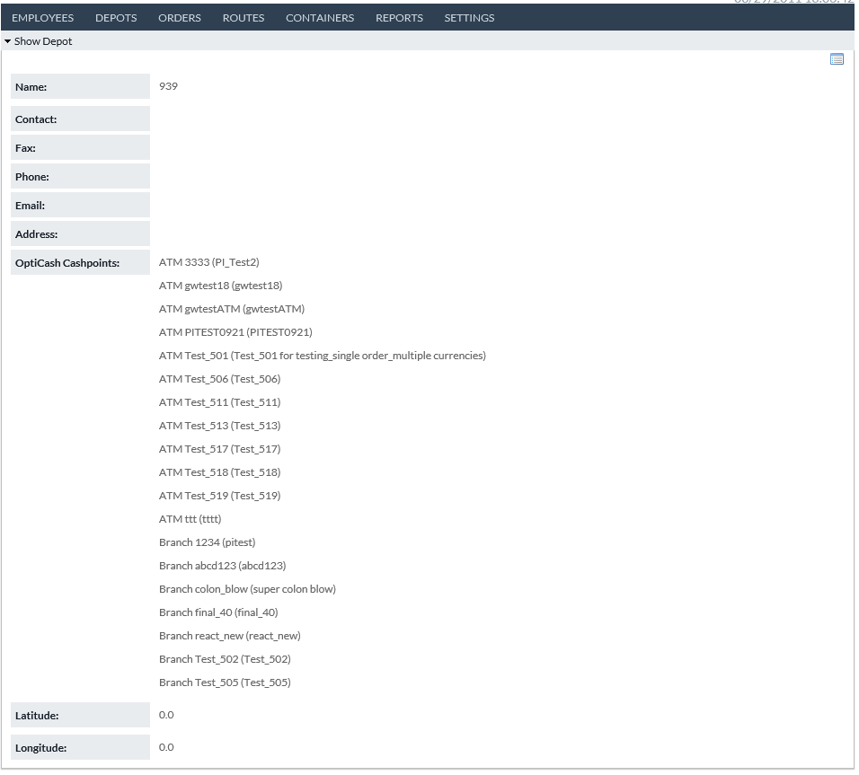

TABLE 9: SHOW DEPOT FIELD DESCRIPTIONS

|  |  |
| --- | --- |
| Field | Description |
| **Name** | Name of the particular Depot |
| **Contact** | Contact person at Depot |
| **Fax** | Fax number for Depot |
| **Phone** | Telephone number for Depot |
| **Address** | Physical Address of Depot |
| **OptiCash Cashpoints** | Provides a full listing of all associated OptiCash cashpoints (ATMs, Branches, & Advanced Devices) |
| **Latitude/Longitude** | The two fields allow CarrierWeb to identify the physical location of the Depot for usage in the OptiTransport route optimization functionality. |

Return to: Depots

## IMPORT VAULT HISTORY

Import Vault History function allows users to load a file containing vault history information (activity and balances). This information is ultimately destined for OptiVault, but this import process allows the data to come in a more flexible format and through CarrierWeb. See separate document Input Output Formats Guide for details on format of that input file.

FIGURE 9: IMPORT VAULT HISTORY SCREEN



Return to: Depots

# ORDERS

Orders is a gateway menu to create, edit, view, action, import, or export orders. Orders are segregated by their type such as Deliveries or Returns for ATM, Branch, Commercial, and Vault cashpoints. Additionally, orders can be filtered by their present state such as In Transit or Ordered.

## CREATE ORDER

###### Create Order directs users to a subset of screens where ATM, Branch, and Vault orders can be generated, as well as Maintenance Visits.

###### FIGURE 10: CREATE ORDER SCREEN

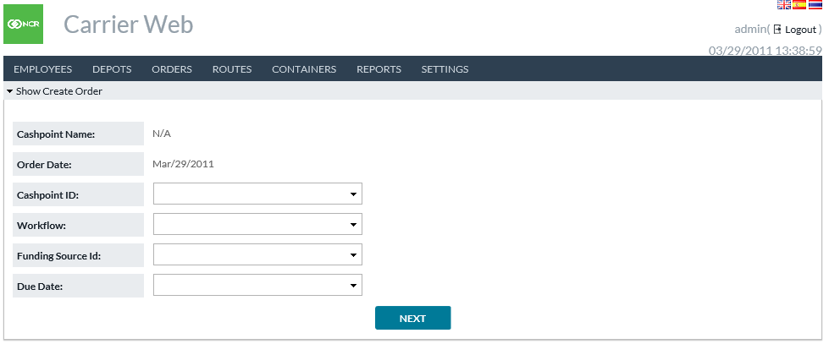

TABLE 10: CREATE ORDER FIELD DEFINITIONS

|  |  |
| --- | --- |
| Field | Description |
| **Cashpoint Name** | Autofills to assigned Cashpoint Name after user selects Cashpoint ID |
| **Order Date** | Defaults to current business day being ordered on |
| **Cashpoint ID** | Drop down list where user selects the unique cashpoint ID order is being placed for.  Note: ATM, Branch, and Vault Create Order screens are identical except for the Funding Source ID field. When user selects ATM, Branch, or Vault from the main Create Order menu, the Cashpoint ID dropdown is automatically filtered to only include IDs of the selected cashpoint type |
| **Workflow** | User selects the type of order to be place: ATM Add Cash, ATM Replace Cash, Branch or Vault Delivery, and Branch or Vault Return. If Emergency orders are utilized they will also be given as unique Workflow types |
| **Due Date** | Users select the service due date for the order being placed |
| **Funding Source ID** | Funding Source ID is used for Vault orders and Branch Transfer orders. This is the other cashpoint involved in the transaction. For Vault Delivery, it is the source of cash. For Vault Return, it is the destination. For Branch Transfer, it is the source of cash. |

Return to: Orders

## CREATE ORDERS - DENOMINATIONS

After selecting cashpoint type, Workflow type, and due date in the initial Create Order screen, users click NEXT and advance to the Create Orders – Denominations screen where the amounts by denomination are entered and the order finalized.

###### FIGURE 9: CREATE ORDER DENOMINATION SCREEN

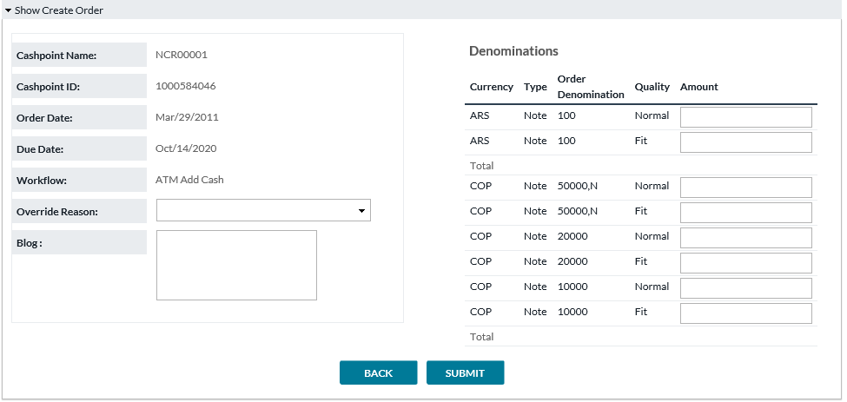

TABLE 11: VAULT SETTINGS FIELD DESCRIPTIONS

|  |  |
| --- | --- |
| Field | Description |
| **Cashpoint Name** | Autofills to assigned Cashpoint Name determined in initial Create Order screen |
| **Cashpoint ID** | Autofills to the cashpoint ID selected in the initial Create Order screen |
| **Funding Source Type (used only for Vault Orders)** | Autofills the cashpoint type of the funding source selected in the initial Create Order screen |
| **Funding Source ID (used only for Vault Orders)** | Autofills the Funding Source ID selected in the initial Create Order screen |
| **Order Date** | Defaults to current business day being ordered on |
| **Due Date** | Defaults to the Due Date selected in the initial Create Order Screen |
| **Workflow** | Defaults to the Workflow type selected in the initial Create Order screen |
| **Override Reason** | Users must select an Override reason from a custom set list of reasons why a non-system recommended order is being placed or edited |
| **Blog** | Shows the time-date flow of actions performed against any order. Will include user ID and each action that has been performed in the processing of the order. |
| **Denominations** | Users select order amounts for each denomination available for the unique cashpoint. For Branch Returns, orders can be defined further by note quality. Similarly for Vaults, if different note qualities can be ordered for the cashpoint each denomination and quality will have its own order field, and users can determine amounts by each denomination and quality individually.  CarrierWeb is multi-currency solution. All denomination-currency combinations will be displayed. |

Return to: Orders

## CREATE ORDERS - MAINTENANCE VISIT

Maintenance Visit is a special type of Order. They can be created and viewed under Orders here, but their primary purpose is for the Route Plan function. For example, if an ATM needs scheduled maintenance, it can be entered this way and included in the Route Plan. Please note that Maintenance Visits have no cash amount, or current status, and are not included in Order-related functions outside of CarrierWeb.

###### FIGURE 11: CREATE MAINTENANCE VISIT

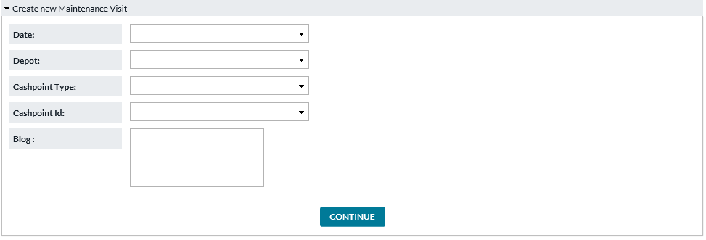

TABLE 12: CREATE MAINTENANCE VISIT FIELD DESCRIPTIONS

|  |  |
| --- | --- |
| Field | Description |
| **Date** | Date on which Maintenance Visit should be performed |
| **Depot** | Depot servicing this cashpoint |
| **Cashpoint Type** | ATM, Branch, Commercial |
| **Cashpoint ID** | The cashpoint which will be visited |
| **Blog** | Comments regarding this Maintenance Visit |

Return to: Orders

## LIST BY WORKFLOW

###### List by Workflow provides a by-type view of all existing orders. Here the user can also filter by current state, order date, and due date.

###### FIGURE 12: LIST ORDERS BY WORKFLOW SCREEN

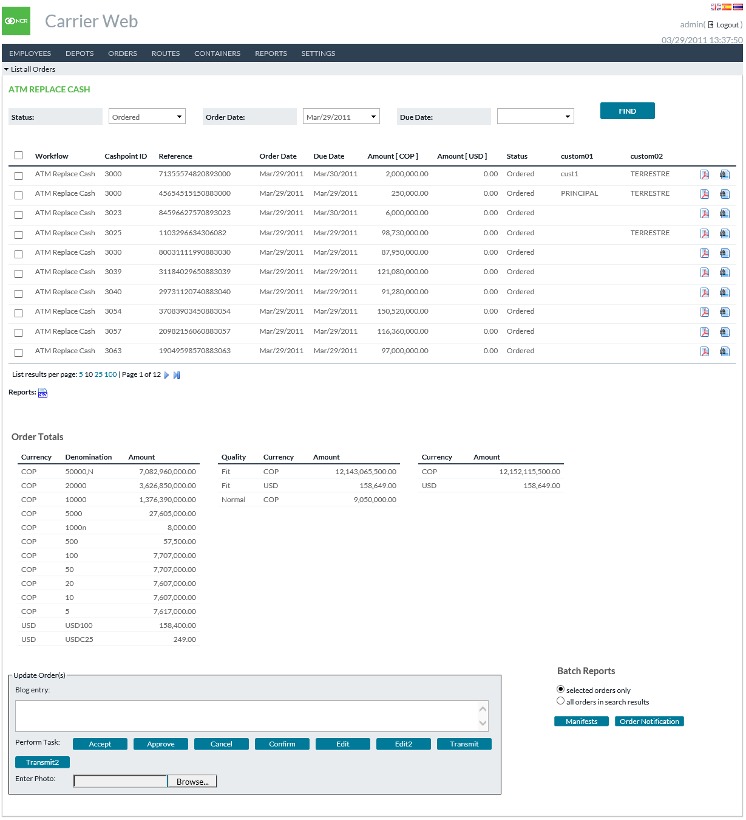

TABLE 13: LIST ORDERS BY WORKFLOW FIELD DESCRIPTIONS

|  |  |
| --- | --- |
| Field | Description |
| **Status (filter)** | User Can Select which unique status they wish to view. Examples are Ordered, In Transit, and cancelled. |
| **Order Date (filter)** | User can select a unique Order Date to select by. |
| **Due Date (filter)** | User can select a unique Due Day to select by. |
| **Workflow** | Shows the Workflow (or order type) for each order. |
| **Cashpoint ID** | The unique cashpoint (ATM, Branch, Vault) identification. This will correlate with the cashpoint IDs defined in the OptiSuite software. |
| **Order Reference** | Unique order identification number. |
| **Order Date** | Date Order was placed in OptiSuite |
| **Due Date** | Date selected by OptiSuite users for actual physical delivery of currency. |
| **Amount [crncy1]** | Amount of the primary currency included in this order. |
| **Amount [crncy2]** | Amount of the secondary currency included in this order. |
| **Status** | Describes current State of the order |
| **Order Totals** | Displays total amount of all orders in the search results. Summed by Denomination (left box), Quality (middle box) and Currency (right box). |
| **Update Orders** | Allows to update the orders by changing status, edit amounts, add notes, etc. Please note that these options are available only if conditions permit (privilege granted, cut-off time not past, etc.) Merely select the orders which will be changed, add a Blog Entry (note), and click one of the task buttons. |
| **Batch Reports** | Allows to generate two types of reports for either selected orders only or all results from the search criteria.  Order Manifests and Order Notifications are the two report options. |
| **Status (filter)** | User Can Select which unique status they wish to view. Examples are Ordered, In Transit, and cancelled. |

Return to: Orders

## SHOW MANIFEST

By clicking on the Show Manifest icon  on the List All Orders screen, the user may access the order manifest for each unique order. Checking the check boxes next to each field cause that field to be updated to the value entered here.

###### FIGURE 13: SHOW MANIFEST SCREEN

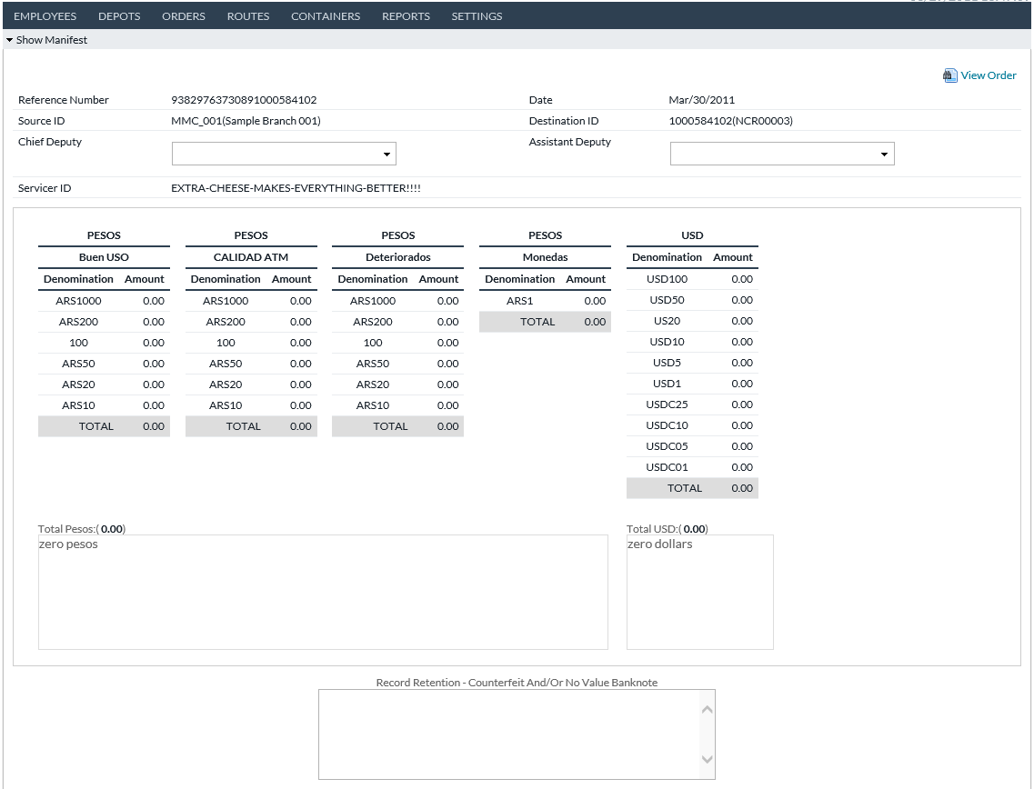

TABLE 14: MANIFEST FIELD DESCRIPTIONS

|  |  |
| --- | --- |
| Field | Description |
| **Reference Number** | Order Reference Number corresponding to OptiSuite unique order ID |
| **Date** | Current Business Day |
| **Source ID** | ID of origination point of currency |
| **Destination ID** | Cashpoint (ATM, Branch, Commercial, Vault) OptiSuite Cashpoint ID |
| **Chief Deputy** | Main Carrier Employee/Agent arriving at service location |
| **Assistant Deputy** | Assistant Carrier Employee/Agent arriving at service location |
| **Servicer ID** | ID of Armored Car Vendor |
| **Order Description** | Currency, Denomination, Denomination Type, and Amount of Order |
| **Comment** | Free text field for additional commentary |
| **Bag Number** | Unique ID for each transported bag |
| **Seal Number** | Unique Seal ID for each unit transported. There could be multiple units contained within a single Bag. Each wallet or unit could require a unique seal |
| **Truck** | Truck ID handling the service call |
| **Check In** | Timestamp that currency was checked in and verified |
| **Arrival** | Arrival timestamp |
| **Back** | Allows users to migrate to the previous screen |
| **Save** | Allows users to save a copy of the Orders Manifest as defined and displayed. |
| **Get Manifest Document** | User can access a pre-formatted printable version of the manifest |

Return to: Orders

## SHOW ORDER

By clicking on the Show Order icon on the List All Orders screen, the user can access detailed information about the description and current state of each unique order.

FIGURE 14: SHOW ORDER SCREEN

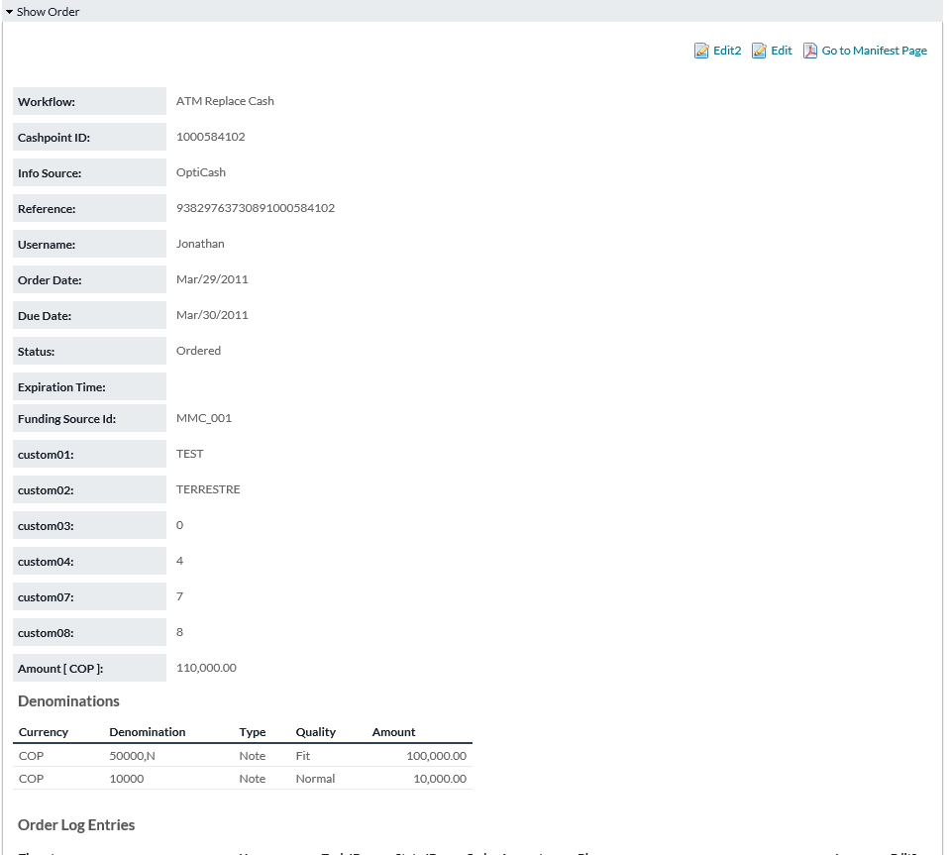

TABLE 15: SHOW ORDER FIELD DESCRIPTIONS

|  |  |
| --- | --- |
| Field | Description |
| **Workflow** | Shows the Workflow (or order type) for each order. Workflows include ATM Add, ATM Replace, ATM Emergency Add, ATM Emergency Replace, Branch Delivery, Branch Return, Branch Emergency Delivery, Branch Emergency Return, Branch Transfer, Commercial Client Delivery, Commercial Client Return, Vault Delivery, Vault Return, Emergency Vault Delivery, and Emergency Vault Return. |
| **Cashpoint ID** | Cashpoint ID to which this order belongs |
| **Info Source** | Order source. OptiCash, OptiVault, or OptiNet |
| **Reference** | Unique Order Identification Number |
| **Username** | Username of person who placed order |
| **Order Date** | Date Order was placed in system |
| **Due Date** | Date Order is due for physical delivery |
| **Status** | Current Status of Order; Ordered, In Transit, et al |
| **Expiration Time** | Timestamp of expiration time of current state. |
| **Funding Source Type** | Depot, Vault, External Funding Source. Describes Funding Source ID below. |
| **Funding Source ID** | ID of the other cashpoint involved in the order. This may be the source of cash, or in the case of a Return order the destination. |
| **Amount [crncy]** | Total amount of the order in primary currency. The primary currency is shown inside []. |
| **Denominations** | Displays the full order by both Denomination and amount by denomination |
| **Order Log Entries** | As the order moves through workflow, a log is kept describing the actions that have occurred. This section describes when, who, and what has occurred and any notes (Blog entries) along the way.  The log maintains a full listing of all Blog entries including the ability to Edit a past log note entry. Date, Time, and User entries cannot be edited, but notes added to a blog can be. |

Return to: Orders

## EDIT ORDER

By choosing the Edit task on List All Orders screen, users access the screen where an existing order can be edited. Users can:

* Edit values in 1-10 Custom Fields
* Alter denomination amounts
* Add notes in the Blog field

Please note: The Edit function is only available if enabled by system administrator.

FIGURE 15: EDIT ORDER SCREEN

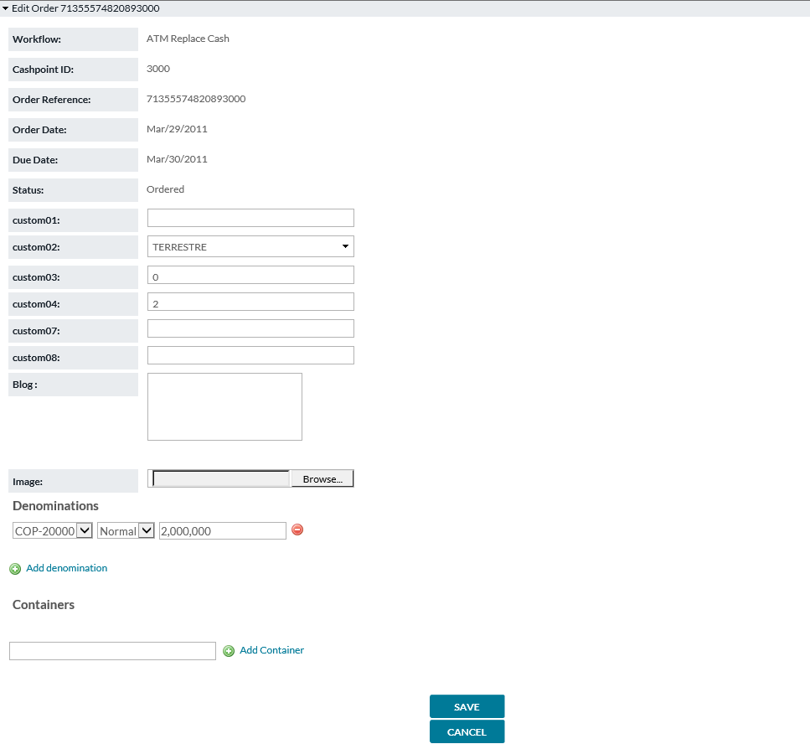

TABLE 16: SHOW ORDER FIELD DESCRIPTIONS

|  |  |
| --- | --- |
| Field | Description |
| **Workflow** | Shows the Workflow (or order type) for each order. |
| **Cashpoint ID** | Cashpoint ID to which this order belongs |
| **Order Reference** | Unique Order Identification Number generated by OptiSuite |
| **Order Date** | Date Order was placed in system |
| **Due Date** | Date Order is due for physical delivery |
| **Currency** | Currency ISO code order describes (USD, EUR, GBP, et al) |
| **Total Amount** | Total Currency Amount of Order |
| **Status** | Current Status of Order; Ordered, In Transit, et al |
| **Custom Field 1-10** | OptiSuite software provides users with up to 10 Custom Fields that are defined by the financial institution. These fields are provided so as to be able to add additional information or instruction regarding orders and their delivery |
| **Denominations** | Displays the denomination detail of cash amounts associated with this order. |

Return to: Orders

## SEARCH ORDERS

Orders→Search allows users to locate orders based upon one or multiple criteria.

FIGURE 16: SEARCH ORDERS SCREEN

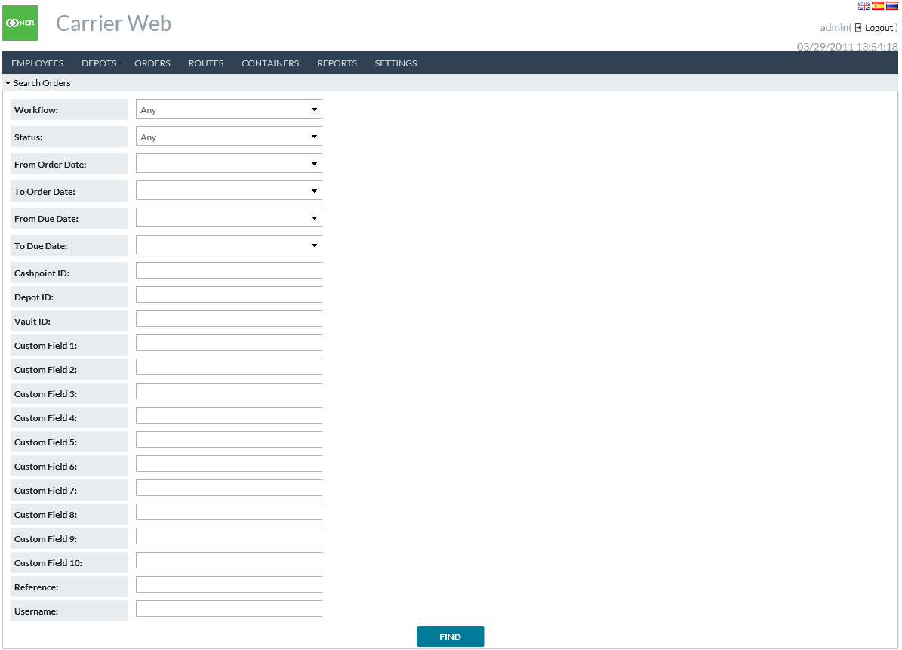

TABLE 17: SEARCH ORDERS FIELD DESCRIPTIONS

|  |  |
| --- | --- |
| Field | Description |
| **Workflow** | Users can designate ANY or a specific workflow (order type). Workflows include ATM Add, ATM Replace, ATM Emergency Add, ATM Emergency Replace, Branch Delivery, Branch Return, Branch Emergency Delivery, Branch Emergency Return, Commercial Client Delivery, Commercial Client Return, Vault Delivery, Vault Return, Emergency Vault Delivery, and Emergency Vault Return. |
| **Status** | Users can designate ANY or a specific status |
| **From/To Order Date** | Users can select a specific Order date range, minimum date, or maximum date. Users may also leave date fields blank to select all orders regardless of Order Date |
| **From/To Due Date** | Users can select a specific Due date range, minimum date, or maximum date. Users may also leave date fields blank to select all orders regardless of Due Date |
| **Cashpoint ID** | Search for Orders belonging to a specific cashpoint |
| **Depot ID** | Search for Orders belonging to a specific Depot |
| **Vault ID** | Search for Orders belonging to a specific Vault |
| **Custom Field 1-10** | Search for Orders having specified values in the respective custom fields. Please note: A custom field may have 1 meaning in OptiCash/OptiNet orders and a different meaning in OptiVault orders. This search may return both. |
| **Reference** | Search for an order using its unique reference number |
| **Username** | Username of the individual who originally created the order |

Return to: Orders

## EXPORT ORDERS

Orders→Export allows users to locate and export orders based upon one or multiple criteria.

FIGURE 17: EXPORT ORDERS SCREEN

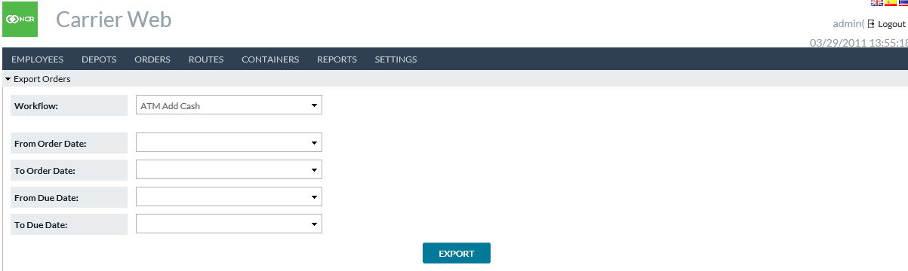

TABLE 18: EXPORT ORDERS FIELD DESCRIPTIONS

|  |  |
| --- | --- |
| Field | Description |
| **Workflow** | Users can designate ANY or a specific workflow. Workflows include ATM Add, ATM Replace, ATM Emergency Add, ATM Emergency Replace, Branch Delivery, Branch Return, Branch Emergency Delivery, Branch Emergency Return, Commercial Client Delivery, Commercial Client Return, Vault Delivery, Vault Return, Emergency Vault Delivery, and Emergency Vault Return. |
| **From/To Order Date** | Users can select a specific Order date range, minimum date, or maximum date. Users may also leave date fields blank to select all orders regardless of Order Date |
| **From/To Due Date** | Users can select a specific Due date range, minimum date, or maximum date. Users may also leave date fields blank to select all orders regardless of Due Date |

Return to: Orders

## IMPORT ORDER UPDATES

Orders→Import Order Updates allows users to import a file containing order updates. Options are given for which type of cashpoints orders will be entered. See separate document Input/Output Formats Guide for content detail of the import file.

FIGURE 18: IMPORT ORDER UPDATES SCREEN

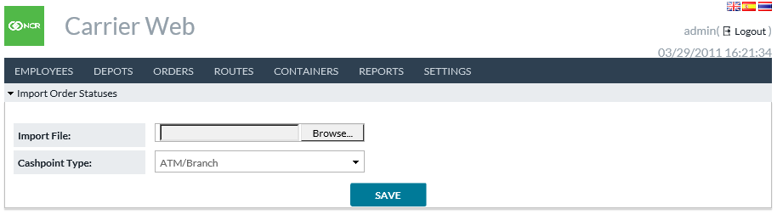

Return to: Orders

## IMPORT ATM RESIDUALS

Orders→Import ATM Residuals allows users to import a file containing ATM residual data. See separate document Input/Output Formats Guide for content detail of the import file.

FIGURE 19: IMPORT ATM RESIDUALS SCREEN

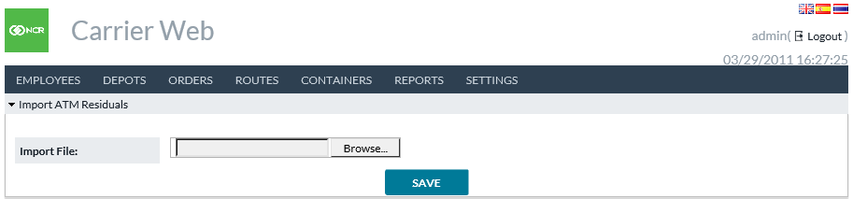

Return to: Orders

## VIEW DISPUTES

Orders→View Disputes shows the current status of disputed orders. Users may use filters to search for disputed orders and click to view additional details of a particular order if desired.

FIGURE 20: VIEW DISPUTES SCREEN

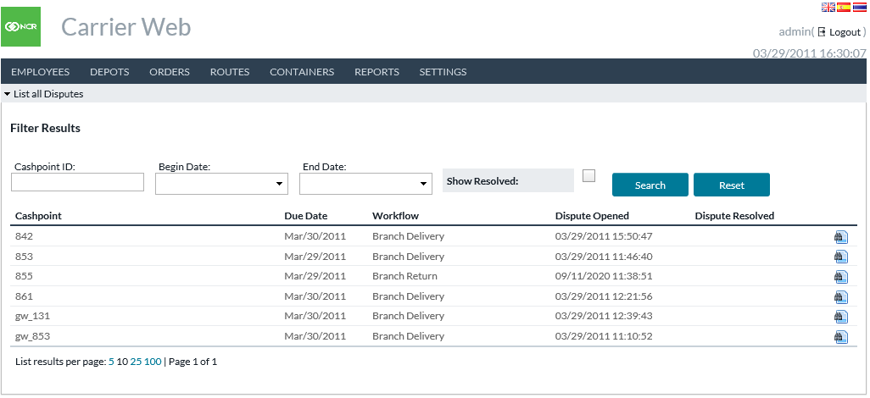

TABLE 19: VIEW DISPUTES FIELD DESCRIPTIONS

|  |  |
| --- | --- |
| Field | Description |
| **Cashpoint ID** | Seach for specific cashpoint(s) if desired. |
| **Begin/End Date** | Date range to search within. This searches Due Date field. |
| **Show Resolved** | Choose whether or not to include Resolved disputes in the search results. |
| **Cashpoint** | The cashpoint for this order. |
| **Due Date** | The date on which this order was intended to execute. |
| **Workflow** | The type of order. Branch Delivery, Branch Return, etc. |
| **Dispute Opened** | The date/time when the dispute was first opened. |
| **Dispute Resolved** | The date/time when the dispute was resolved, or blank if not resolved. |

Return to: Orders

## INPUT DISPUTES

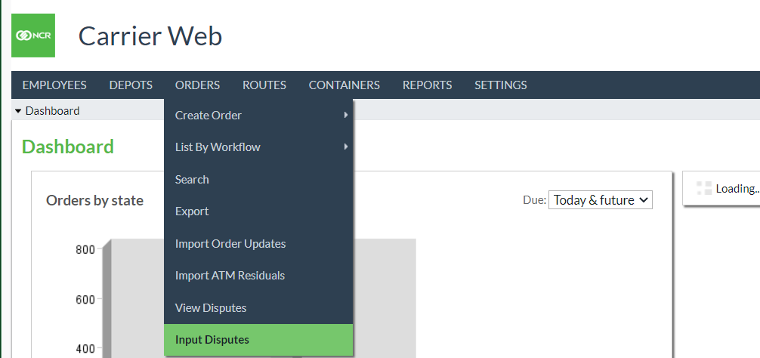

Orders→Input Disputes shows all Branch Return Orders (planned and unplanned). Users may use filters to search for confirmed, disputed orders and click to view additional details of a particular order if desired. Users can also view manifest, click to create/update dispute details for an order.

|  |  |
| --- | --- |
| Field | Description |
| **Due Date** | The date on which this order was intended to execute. |
| **Order Date** | The date on which this order was created. |
| **Status** | The order state (Confirmed, Disputed) |
| **Order Reference** | The reference for the particular order. |

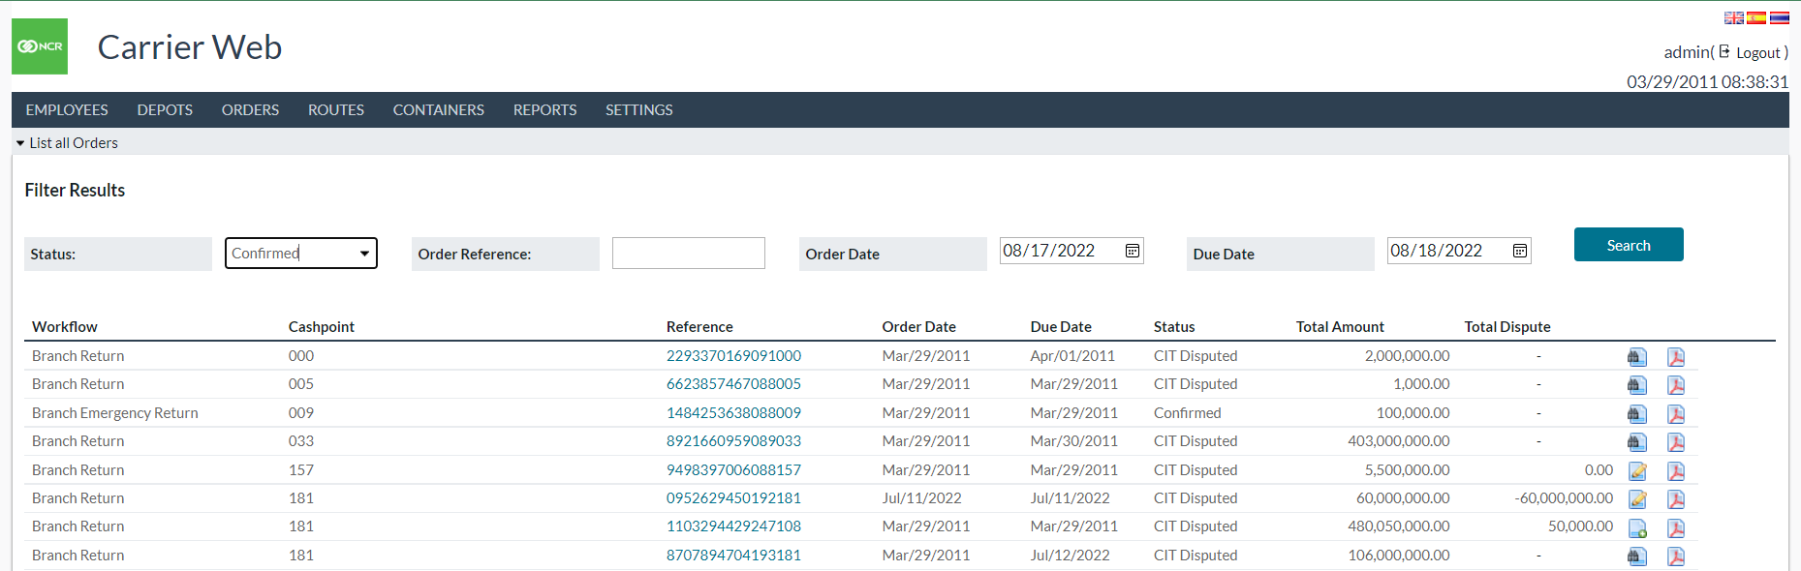

User can click on the order reference to go to order screen and click on Count Issue task to change order state to Disputed and then click on Edit task to enter amount received and the difference from the actual ordered value vs the received amount will be calculated and saved as the dispute amount.

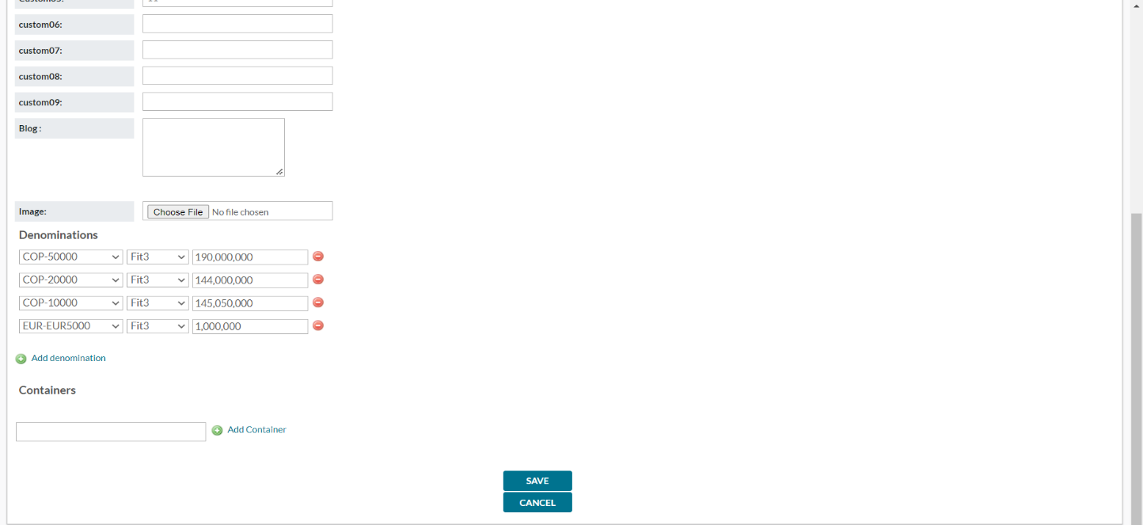

Create/Update Dispute Details

User can click on create dispute or update dispute icon to enter dispute details or update them respectively along with supporting evidence so that the total amount of dispute matches the earlier calculated dispute amount and save dispute details.

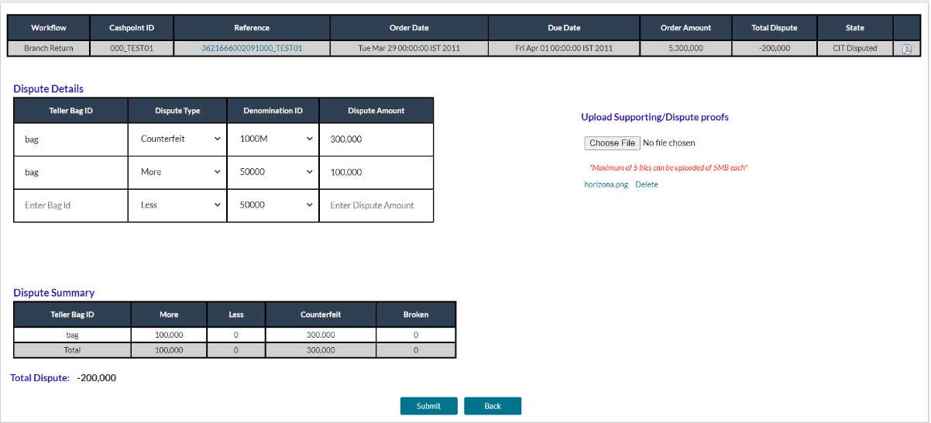

Depending on the edit made in CarrierWeb to branch return orders the disputed amount (amount difference between actual order and edited order) will be calculated and fixed which we can see in this image in the order detail table’s Total Dispute field.

After receiving order, Carrier-Web users can populate the details in Dispute Detail table which then generate Dispute Summary table in real-time. Evidence of these disputes can also be attached as image or pdf file type.

|  |  |
| --- | --- |
| Field | Description |
| **Teller Bag Id** | Individual order bag identifier. |
| **Dispute Type** | Dropdown to select dispute type. By default, the 4 available dispute types are: -   * More: If the amount exceeds compared to what declared in manifest. * Less: If the amount is less as compared to what declared in manifest. * Counterfeit: If the received currency bills are invalid. * Broken: If the bills received are not in proper condition and therefore are not usable. |
| **Denomination Id** | Dropdown to select a denomination id from Cashpoint level defined denominations. |
| **Dispute Amount** | Numeric Text Field to enter dispute amount for the given bag id, denomination id and dispute type. |

The Dispute Summary table shows the different amounts of disputes of all types for each bag ID, and the total dispute amount is also shown below this table.

The Save button will only be enabled if the total dispute amount below the dispute summary table matches the amount in Total Dispute column at the top of the screen.

# ROUTES

Routes is a gateway menu to create, review, and plan delivery routes. Records about the vehicles (Trucks) servicing those routes are also found here.

## CREATE NEW ROUTE

###### Routes→Create New allows users to create a new route plan.

FIGURE 21: CREATE NEW ROUTE SCREEN

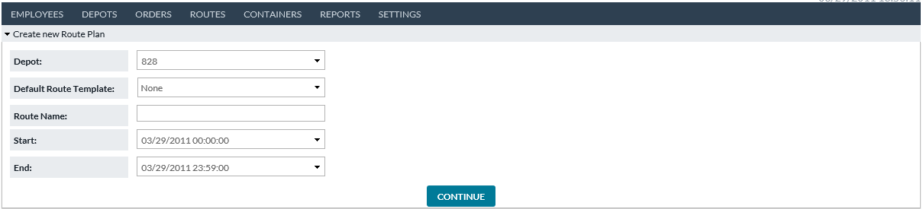

TABLE 20: CREATE NEW ROUTE FIELD DESCRIPTIONS

|  |  |
| --- | --- |
| Field | Description |
| **Depot** | Each route is assigned to a unique Depot. Users select from the predefined dropdown of depots |
| **Default Route Template** | A Default Route to use for this route plan. The Default Route functions as a template and choices made there will prepopulate values in this route plan on the following page. |
| **Route Name** | User-chosen name for this route plan. |
| **Start** | Date and time to begin this route execution. Pairs with End below. |
| **End** | Date and time to finish this route execution. Note: Truck and Driver resources are considered allocated during this time period and other Route Plans may not use them during the same time period. |
| **Continue** | Button takes the user to CREATE/UPDATE ROUTE PLAN DETAIL to finish defining the route plan. |

Return to: Routes

## LIST ALL ROUTES

###### Routes→List All provides users with a listing of all existing routes.

FIGURE 14: LIST ALL ROUTES SCREEN

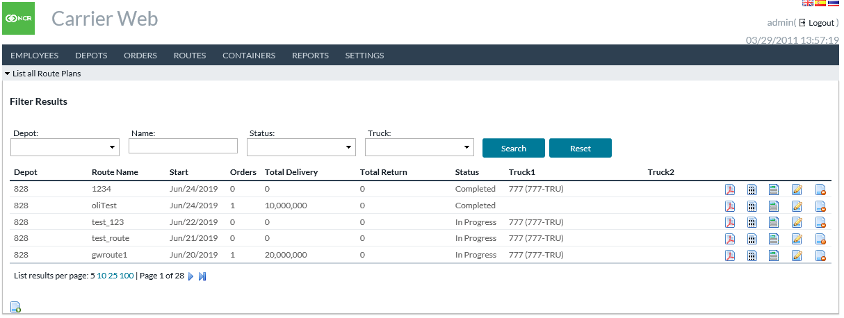

TABLE 21: LIST ALL ROUTES FIELD DESCRIPTIONS

|  |  |
| --- | --- |
| Field | Description |
| **Depot** | Depot the route is associated with |
| **Route Name** | Unique user-defined route name |
| **Date** | Date of execution of this Route Plan |
| **Orders** | Number of existing orders |
| **Total Delivery** | Total Outstanding Deliveries for the route |
| **Total Return** | Total Outstanding Returns for the route |
| **Status** | Status of the route |
| **Truck** | Unique Truck Identification Code |

Return to: Routes

## ROUTE PLAN DOCUMENT

By clicking on the Route Plan icon on the List All Routes screen, the user accesses a printable pdf Route Plan document that includes Truck Identification, Driver Identification, Additional Security Identification, cashpoint-by-cashpoint details including arrival and departure times, and order details. Total mileage is also able to be recorded on the form.

##### FIGURE 22: PRINTABLE ROUTE PLAN

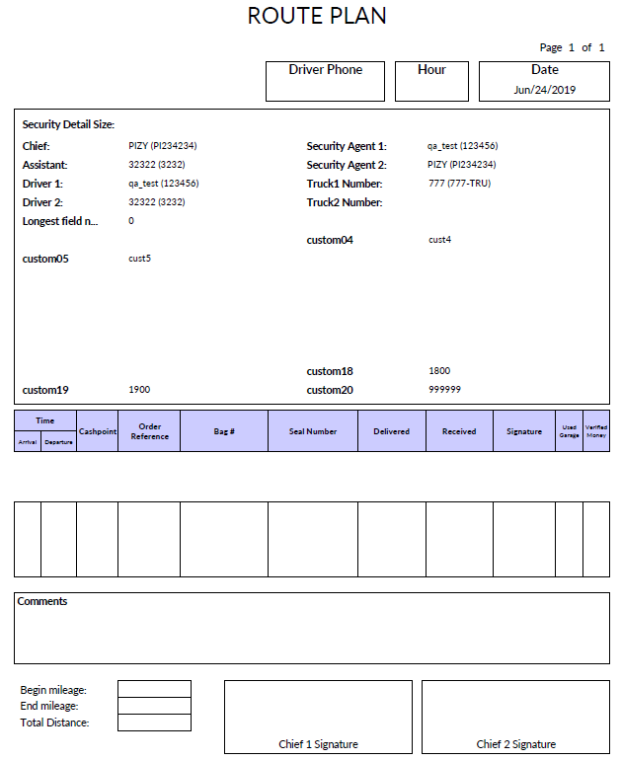

Return to: Routes

## ROUTE PLAN AUDIT

By clicking on the Route Plan Audit icon  on the List All Routes screen, users may view the change history of the Route Plan.

##### FIGURE 23: ROUTE PLAN AUDIT SCREEN

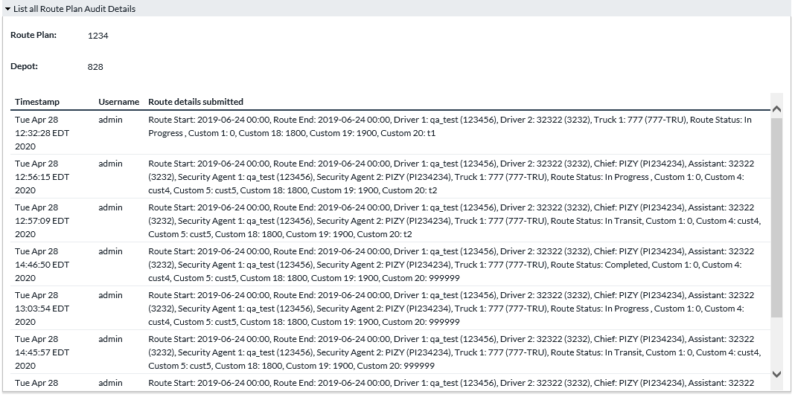

Table 22: ROUTE PLAN AUDIT FIELD DESCRIPTIONS

|  |  |
| --- | --- |
| Field | Description |
| **Timestamp** | Date and time when a change occurred. |
| **Username** | Username who made the change. |
| **Route Details Submitted** | Details given for the route (changed to this) |

Return to: Routes

## CREATE/UPDATE ROUTE PLAN DETAIL

By clicking on the Edit Route Plan icon on the List All Routes screen, or Continue button on Create New Route Plan, the user accesses the screen where attributes of the route can be defined. Portions of the screen are interactive allowing editing and planning of routes.

##### FIGURE 24: CREATE/UPDATE ROUTE PLAN SCREEN

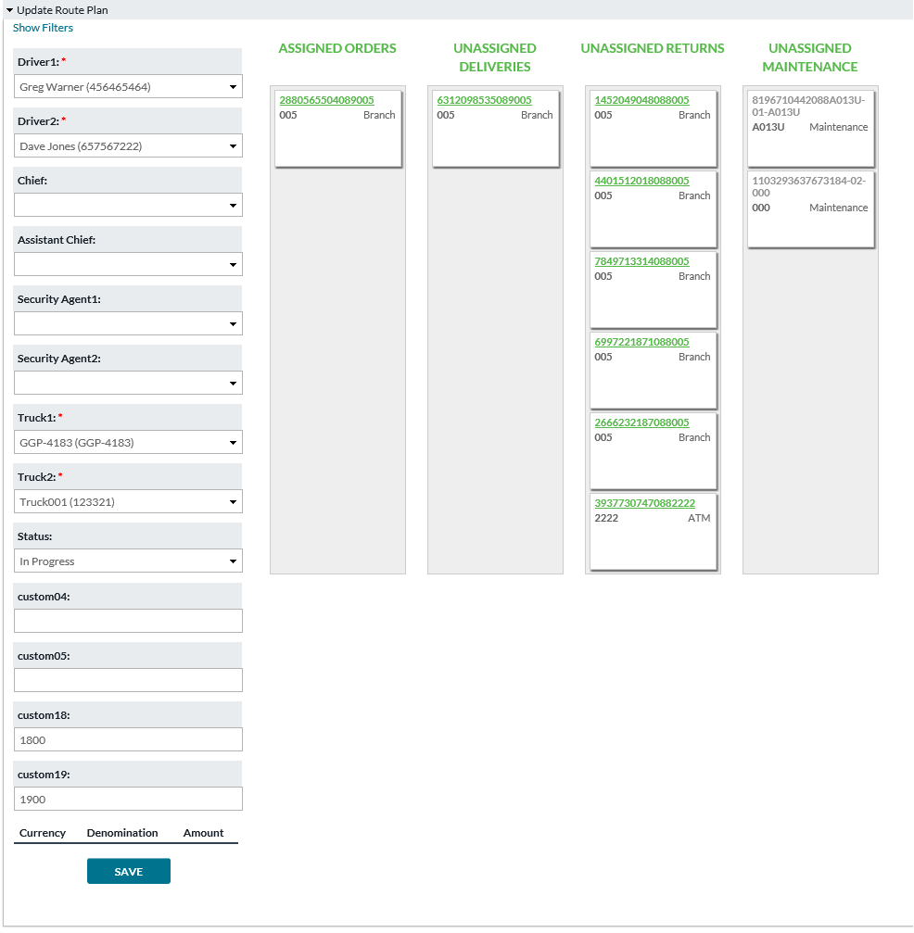

Table 23: CREATE/UPDATE ROUTE PLAN FIELD DESCRIPTIONS

|  |  |
| --- | --- |
| Field | Description |
| **Calculate Shortest Path** | With the optional OptiTranport license, this function can arrange the stops in the route according to optimal sequence. For more information regarding this feature please reference Appendix A: OptiTransport in the guide.  Note: If OptiTransport has not been licensed Calculate Shortest Path will not be visible. |
| **Show/Hide Filters** | Panel to optionally filter the orders available to be added to this Route Plan. |
| **Depot** | Depot with which the route is associated |
| **Route Name** | User-defined route name |
| **Date** | Current Business Date |
| **Driver1** | Name of Primary Driver |
| **Driver2** | Name of Secondary or substitute Driver |
| **Driver3** | Name of Tertiary or substitute Driver |
| **Chief** | Additional field available for identifying members of route delivery crew |
| **Assistant Chief** | Additional field available for identifying members of route delivery crew |
| **Security Agent1** | Additional field available for identifying members of route delivery crew |
| **Security Agent2** | Additional field available for identifying members of route delivery crew |
| **Truck** | Unique Truck Identification code |
| **Status** | Status of Route Plan. Statuses follow a workflow configured by your institution. For example: In Progress > In Transit > Completed. Note: Route Plan fields may disable (become read only) when certain statuses are reached. Additionally, changing the Route Plan’s status may initiate order updates. See ROUTE PLAN WORKFLOW |
| **Assigned Orders** | Interactive portion of screen showing individual orders that make up the assigned route. Order tiles can be clicked and drug between columns to aid in the planning of routes.  Assigned Orders column reflects only those orders that are assigned to the route being reviewed/edited. |
| **Unassigned Deliveries** | Interactive portion of screen showing individual orders that can be added to the route. Order tiles can be clicked and drug between columns to aid in the planning of routes.  Unassigned Deliveries column reflects only those deliveries that are not yet assigned to a route. |
| **Unassigned Returns** | Interactive portion of screen showing individual orders that can be added to the route. Order tiles can be clicked and drug between columns to aid in the planning of routes.  Unassigned Returns column reflects only those returns that are not yet assigned to a route. |
| **Unassigned Maintenance** | Interactive portion of screen showing individual orders that can be added to the route. Order tiles can be clicked and drug between columns to aid in the planning of routes.  Unassigned Maintenance column reflects only those Maintenance Visits that are not yet assigned to a route. |

Return to: Routes

## MANAGE TRUCKS

Routes→Manage Trucks provides access for users to define and control the vehicles in service.

The primary screen under Manage Trucks is the List All Trucks screen which gives a single list of all in-service trucks.

###### FIGURE 25: LIST ALL TRUCKS SCREEN

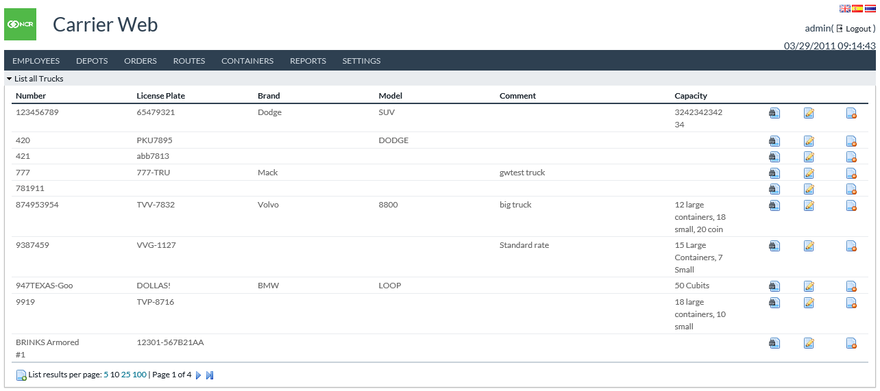

Table 24: LIST ALL TRUCKS FIELD DESCRIPTIONS

|  |  |
| --- | --- |
| Field | Description |
| **Number** | Unique Truck Identification code |
| **License Plate** | Government-issued license plate number of the truck |
| **Brand** | Make of Truck (Volvo, Ford, and others) |
| **Model** | Particular model of truck to aid in identification |
| **Comment** | Free Text field providing ability to notate additional helpful information regarding each truck |
| **Capacity** | Total hauling capacity of each truck |

Return to: Routes

## SHOW TRUCK

###### By clicking on the Show Truck icon on the List All Trucks screen, the user accesses detailed information regarding each truck. Show Truck screen also provides gateway icons to add new trucks or edit an existing one.

###### FIGURE 26: SHOW TRUCK SCREEN

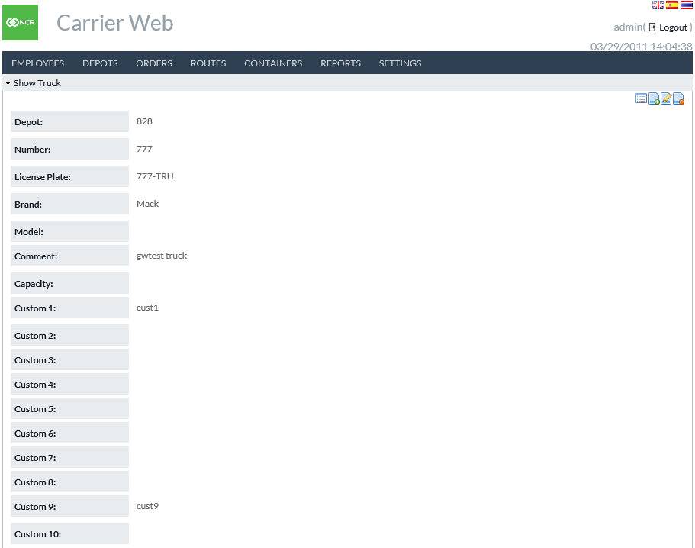

Table 25: SHOW TRUCK FIELD DESCRIPTIONS

|  |  |
| --- | --- |
| Field | Description |
| **Depots** | Depots with which this truck associates |
| **Number** | Unique Truck Identification code |
| **License Plate** | Government-issued license plate number of the truck |
| **Brand** | Make of Truck (Volvo, Ford, and others) |
| **Model** | Particular model of truck to aid in identification for security purposes |
| **Comment** | Free Text field providing ability to notate additional helpful information regarding each truck |
| **Capacity** | Total hauling capacity of each truck |
| **Custom 1-10** | Ten available custom fields to provide additional description fields for usage in defining trucks |

Return to: Routes

## CREATE NEW TRUCK

By clicking on the Create New Truck icon  on Manage Trucks page, administrators access the ability to create new trucks. For field descriptions please refer to Show Truck

FIGURE 27: CREATE TRUCK SCREEN

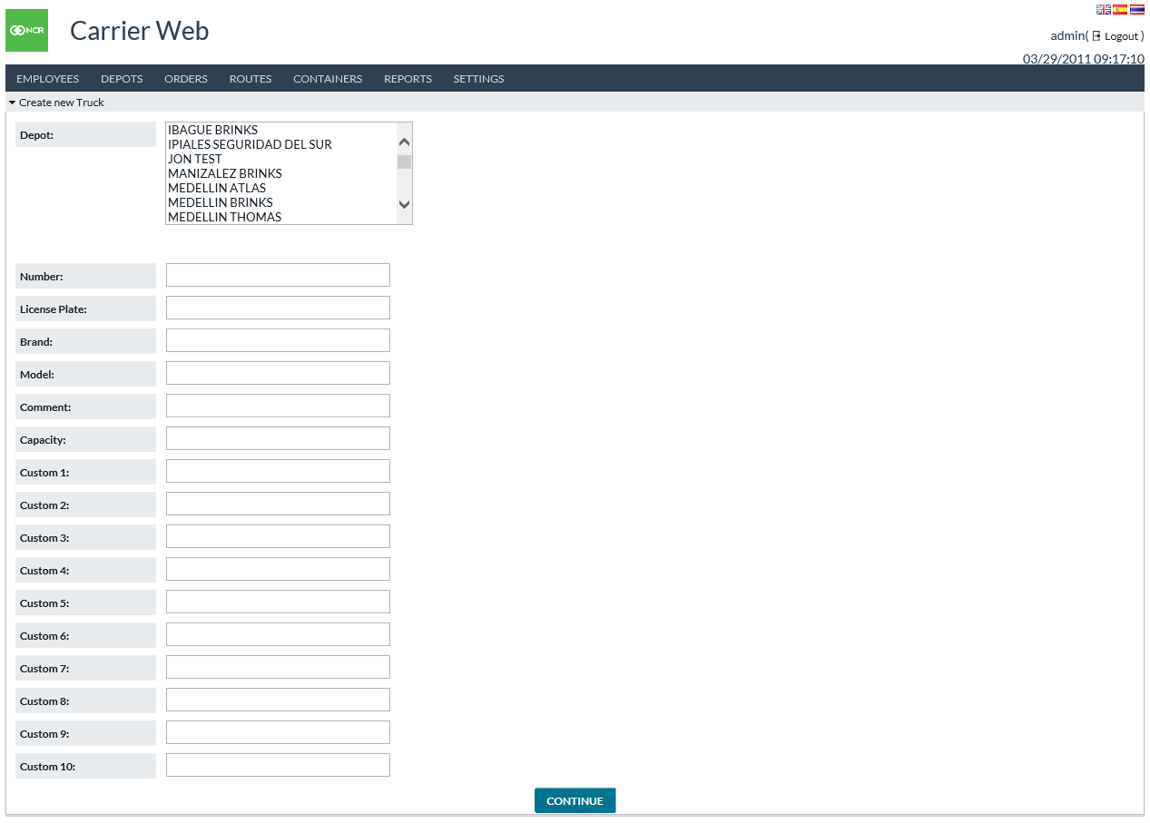

Return to: Routes

## MANAGE DEFAULT ROUTES

Routes→Manage Default Routes provides access to standard routes. These are similar to templates for routes. Default Routes can be created and edited by navigating via the icons on the screen.

##### FIGURE 28:LIST DEFAULT ROUTES SCREEN

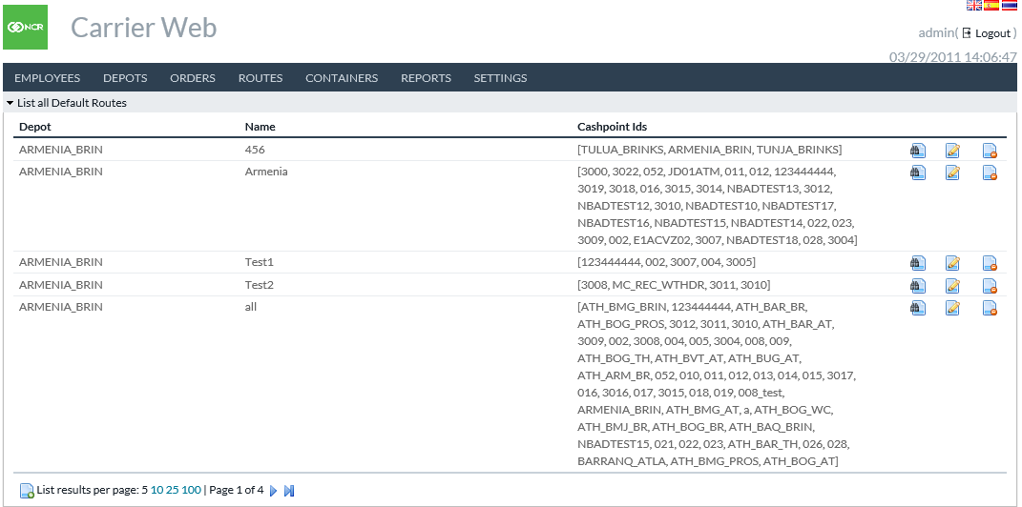

###### Table 26: LIST DEFAULT ROUTES FIELD DESCRIPTIONS

|  |  |
| --- | --- |
| Field | Description |
| **Depot** | Depot with which the route is associated. |
| **Name** | Unique name of route |
| **Cashpoint IDs** | OptiSuite defined ids of the cashpoints included on the default route. When a new Route Plan is created using this default, then orders for these cashpoints will be included by default (users may change afterward if desired). |

Return to: Routes

## SHOW DEFAULT ROUTE

By clicking on the Show Default  Route icon administrator users can access detailed information about each default route. For field descriptions please see Update Default Route below.

## UPDATE DEFAULT ROUTE

By clicking on the Update Default Route icon administrator users can edit existing default routes.

##### FIGURE 29:UPDATE DEFAULT ROUTES SCREEN

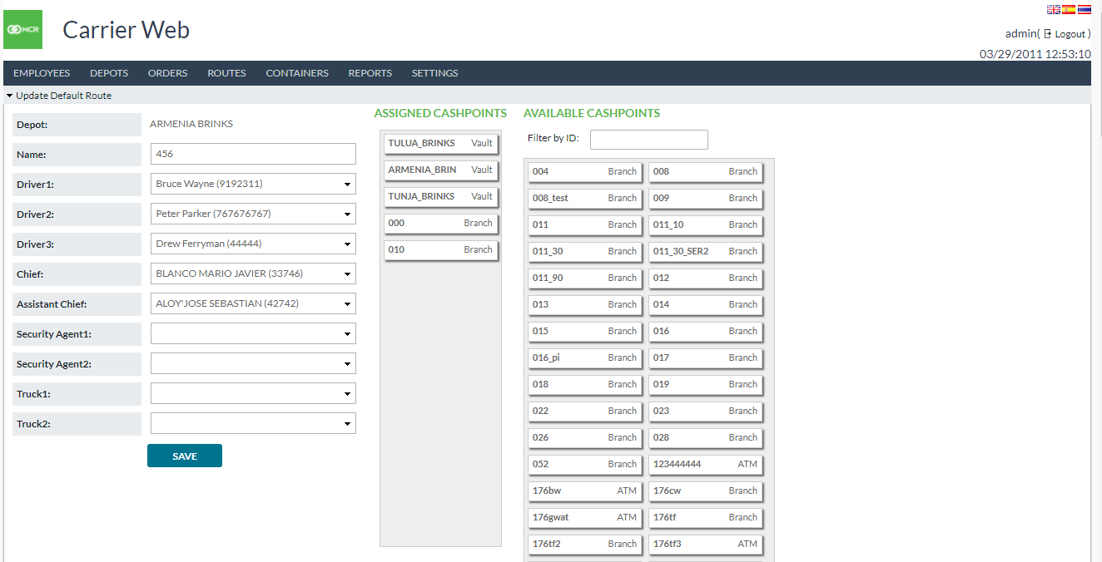

###### Table 27: UPDATE DEFAULT ROUTES FIELD DESCRIPTIONS

|  |  |
| --- | --- |
| Field | Description |
| **Depot** | Depot the route is associated with |
| **Route Name** | Unique user-defined route name |
| **Date** | Current Business Date |
| **Status** | Current state of Order |
| **Driver1** | Name of Primary Driver |
| **Driver2** | Name of Secondary or substitute Driver |
| **Driver3** | Name of Tertiary or substitute Driver |
| **Chief** | Supervisor/Manager level in charge of currency handling and delivery |
| **Assistant Chief** | Additional Supervisor/Manager level in charge of currency handling and delivery |
| **Security Agent1** | Available field for defining additional security personnel in currency handling and delivery |
| **Security Agent2** | Available field for defining additional security personnel in currency handling and delivery |
| **Truck** | Unique Truck Identification code |
| **Assigned Cashpoints** | Interactive Portion of Screen showing individual cashpoints that make up the assigned route. Cashpoint Windows can be clicked and drug between Assigned and Available Cashpoints to aid in the ease and speed of planning routes.  Assigned Cashpoints column reflects only those that are assigned to the default route being reviewed/edited. |
| **Available Cashpoints** | Interactive Portion of Screen showing individual cashpoints that make up the assigned route. Cashpoint Windows can be clicked and drug between Assigned and Available Cashpoints to aid in the ease and speed of planning routes.  Available Cashpoints column reflects only those that are not yet assigned to a route. |

Return to: Routes

# CONTAINERS

Containers refer to ATM cassettes, deposit bags, etc. A physical container which holds cash during transfer between locations. CarrierWeb allows to record an inventory of containers and track their movements between locations. This is often, but not always, connected to Orders.

## IMPORT CONTAINERS

###### Containers→Import allows users to create containers by importing from a file. See separate document “Input Output Formats Guide” for format detail of that file.

FIGURE 30: IMPORT CONTAINERS SCREEN

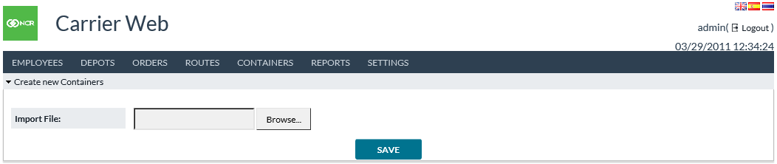

Return to: Containers

## CREATE NEW CONTAINER

###### Containers→Create New allows users to create a single container.

FIGURE 31: CREATE NEW CONTAINER SCREEN

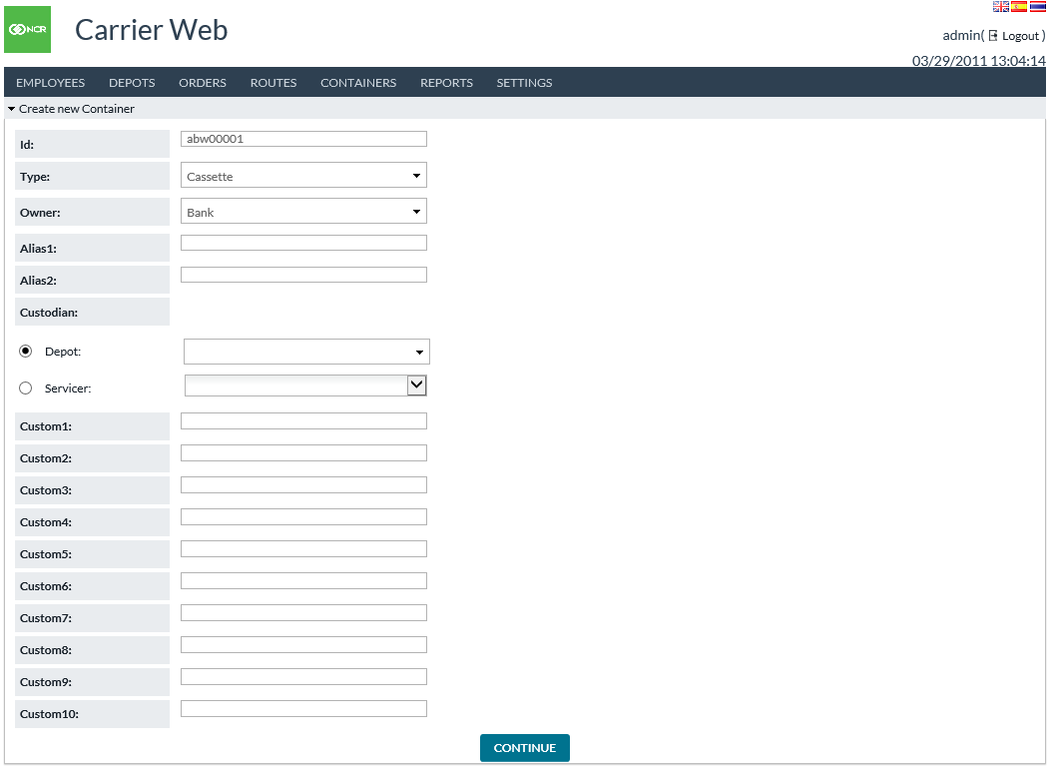

###### Table 28: CREATE NEW CONTAINER FIELD DESCRIPTIONS

|  |  |
| --- | --- |
| Field | Description |
| **Id** | An identifier for the container to be created. Must be different than other container IDs already in use. |
| **Type** | Type of container. Options may be configured by your institution. |
| **Owner** | Owner entity for this container. Options may be configured by your institution. |
| **Alias1, Alias2** | Optional alternative identifiers for the container. For example, a manufacturer’s serial number (if different from the main ID). |
| **Custodian** | Entity responsible for this container. Refers to a Depot or Servicer from OptiCash. This is part of access control: only users associated with the chosen Depot or Servicer are able to use this container. |
| **Custom1-10** | Container fields whose meaning may be customized by your institution. |

Return to: Containers

## CONTAINER BULK CREATION

###### Containers→Bulk Creation allows users to create multiple containers in a block. Each container will be created with a different ID according to a sequence. For example: ABB0001, ABB0002, ABB0003, etc. The numeric part of sequence will begin larger than whatever largest value already exists with the same prefix – so if ABB0003 already exists, then Bulk Creation automatically starts with ABB0004. User may choose how many containers to create in this block. Containers will be created with like values for all fields other than container ID.

FIGURE 32: CONTAINER BULK CREATION SCREEN

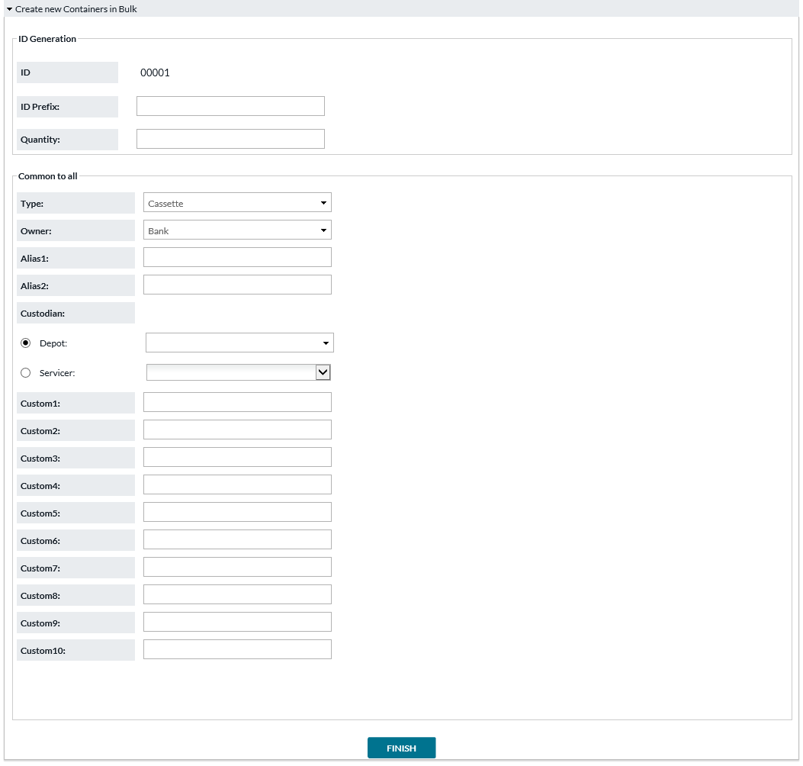

###### Table 29: CONTAINER BULK CREATION FIELD DESCRIPTIONS

|  |  |
| --- | --- |
| Field | Description |
| **Id** | A preview display of the container IDs that will be created. Based on prefix if entered below, and system setting Bulk Container Creation Sequence Length. |
| **Id Prefix** | Prefix to appear in front of the numeric sequence in container IDs. |
| **Quantity** | Number of containers to create in this block. |
| **Type** | Type of container. Options may be configured by your institution. |
| **Owner** | Owner entity for this container. Options may be configured by your institution. |
| **Alias1, Alias2** | Optional alternative identifiers for the container. For example, a manufacturer’s serial number (if different from the main ID). |
| **Custodian** | Entity responsible for this container. Refers to a Depot or Servicer from OptiCash. This is part of access control: only users associated with the chosen Depot or Servicer are able to use this container. |
| **Custom1-10** | Container fields whose meaning may be customized by your institution. |

Return to: Containers

## LIST ALL CONTAINERS

###### Containers→List All allows users to view and modify containers. Container location moves and custodian assignments may be done here, as well as update and delete container fields.

FIGURE 33: LIST ALL CONTAINERS SCREEN

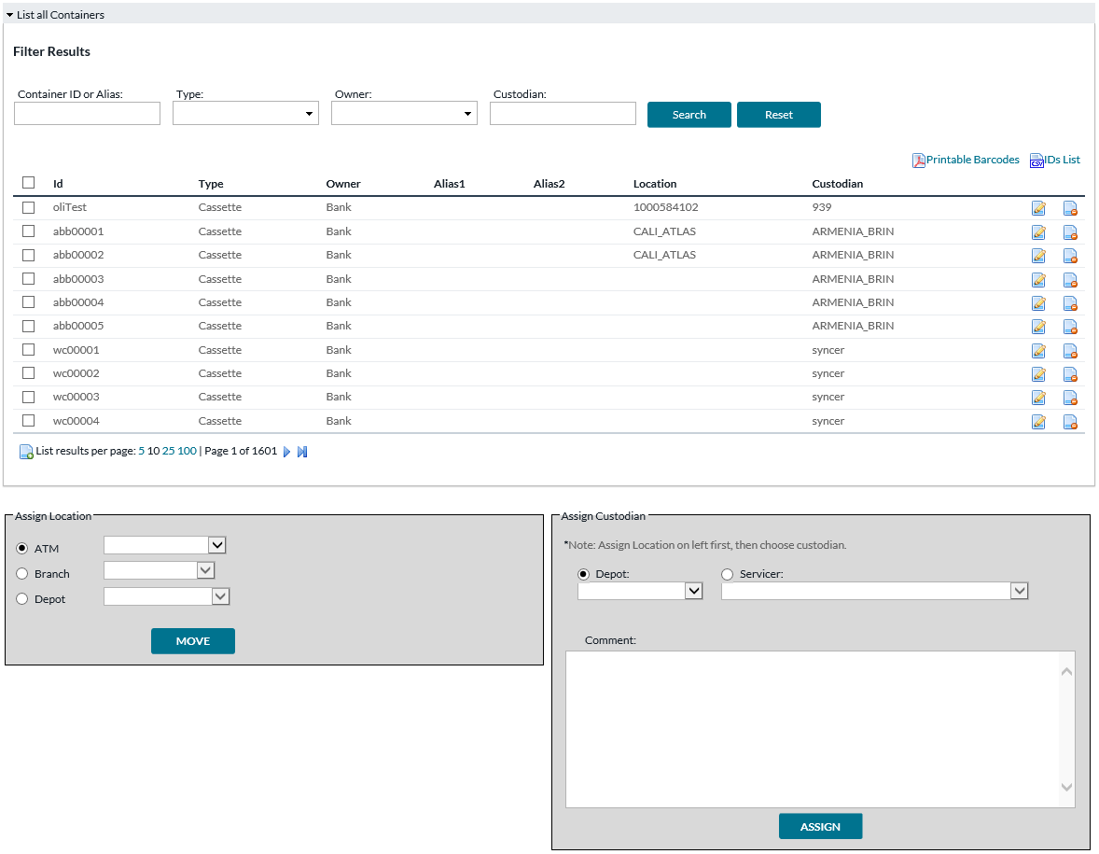

###### Table 30: LIST ALL CONTAINERS FIELD DESCRIPTIONS

|  |  |
| --- | --- |
| Field | Description |
| **Printable Barcodes** | Opens a PDF file containing the barcode of Container IDs for the listed containers. |
| **IDs List** | Opens a CSV file containing the IDs of the listed containers. |
| **Id** | A preview display of the container IDs that will be created. Based on prefix if entered below, and system setting Bulk Container Creation Sequence Length. |
| **Type** | Type of container. Options may be configured by your institution. |
| **Owner** | Owner entity for this container. Options may be configured by your institution. |
| **Alias1, Alias2** | Optional alternative identifiers for the container. For example, a manufacturer’s serial number (if different from the main ID). |
| **Location** | Current last known location of the container. |
| **Custodian** | Entity responsible for this container. Refers to a Depot or Servicer from OptiCash. This is part of access control: only users associated with the chosen Depot or Servicer are able to use this container. |
| **Edit button** | Opens the Edit Container page described below. Page is for changing the properties of the container. |
| **Delete button** | Deletes the associated container. |
| **Assign Location** | To manually move location of selected containers, choose the new location and click Move button. |
| **Assign Custodian** | To change custodian of selected containers, choose the new custodian, optionally add a comment, and then click Assign button. Note: If doing a container handover that involves changing both Location and Custodian for containers, do the Location change first, since the Custodian change may cause you to lose access to the containers. |

###### If user clicks Edit button, then screen below is shown.

FIGURE 34: EDIT CONTAINER

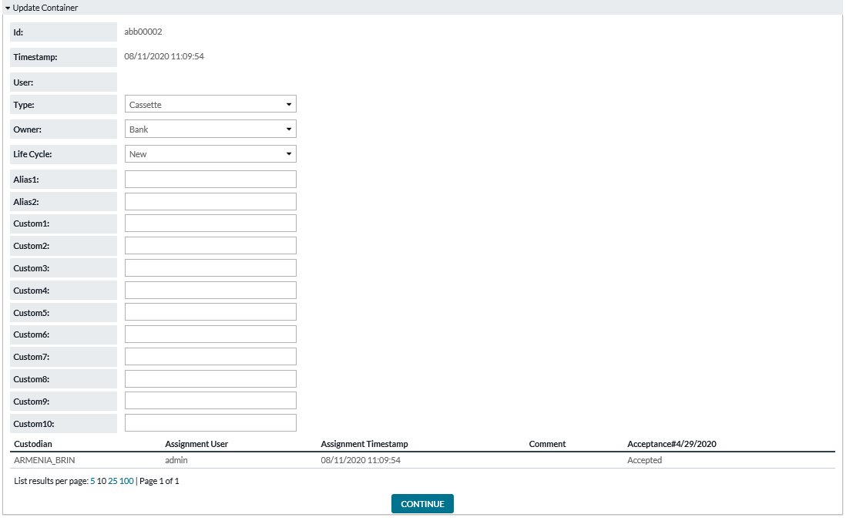

###### Table 31: EDIT CONTAINER FIELD DESCRIPTIONS

|  |  |
| --- | --- |
| Field | Description |
| **Id** | A preview display of the container IDs that will be created. Based on prefix if entered below, and system setting Bulk Container Creation Sequence Length. |
| **Type** | Type of container. Options may be configured by your institution. |
| **Owner** | Owner entity for this container. Options may be configured by your institution. |
| **Life Cycle** | Indicates what life cycle stage this container is in. New, In Use, Damaged, Missing, etc. – these options may be customized by your institution. |
| **Alias1, Alias2** | Optional alternative identifiers for the container. For example, a manufacturer’s serial number (if different from the main ID). |
| **Custom 1-10** | Container fields whose meaning may be customized by your institution. |

Return to: Containers

## CONTAINER LOCATIONS

###### Containers→Locations allows the user to either find the location of specific containers, or find a location and list what containers are currently there.

FIGURE 35: CONTAINER LOCATIONS SEARCH SCREEN



###### Table 32: CONTAINER LOCATIONS SEARCH FIELD DESCRIPTIONS

|  |  |
| --- | --- |
| Field | Description |
| **Search by Container** | Option to search for containers. User may type all or part of a container’s ID or Alias1/Alias2, then press Find button. |
| **Search Locations** | Option to search for location. User may type all or part of the location ID, then press Find button. |

###### If user chooses to Search by Container, then the results page looks like below.

FIGURE 36: CONTAINER SEARCH RESULTS SCREEN

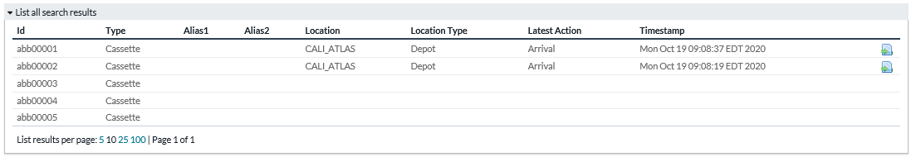

###### Table 33: CONTAINER SEARCH RESULTS FIELD DESCRIPTIONS

|  |  |
| --- | --- |
| Field | Description |
| **Id** | A preview display of the container IDs that will be created. Based on prefix if entered below, and system setting Bulk Container Creation Sequence Length. |
| **Type** | Type of container. Options may be configured by your institution. |
| **Owner** | Owner entity for this container. Options may be configured by your institution. |
| **Alias1, Alias2** | Optional alternative identifiers for the container. For example, a manufacturer’s serial number (if different from the main ID). |
| **Location** | Current last known location of the container. |
| **Location Type** | ATM, Branch, or Depot |
| **Latest Action** | Arrival, Departure, or Confirm. |
| **Timestamp** | Date and time when Latest Action occurred. |
| **Move button** | Allows user to manually move the container to a new location. |

###### If user chooses to Search Locations, then the results page looks like below.

FIGURE 37: LOCATION SEARCH RESULTS SCREEN

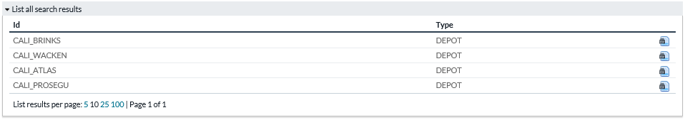

###### Table 34: LOCATION SEARCH RESULTS FIELD DESCRIPTIONS

|  |  |
| --- | --- |
| Field | Description |
| **Id** | Location ID. |
| **Type** | Type of location. ATM, Branch, or Depot |
| **View button** | Allows user to see a list of the containers currently at that location. |

Return to: Containers

## CONTAINER ALERTS

###### Containers→Alerts allows users to view alert messages regarding container actions. For example: A container was marked present at a location (during Stock Taking), or a container was marked missing at an ATM when the order record said it should have been there.

FIGURE 38: CONTAINER ALERTS SCREEN

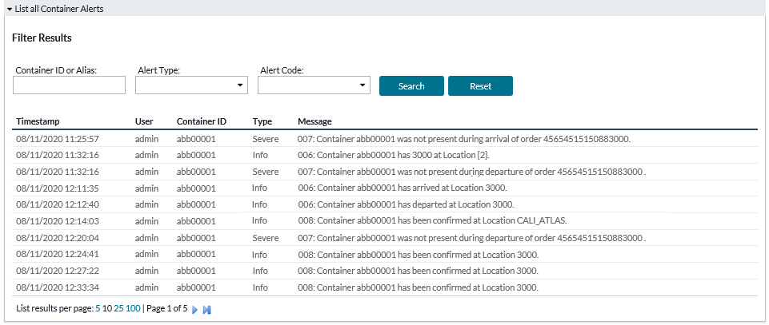

###### Table 35: CONTAINER ALERTS FIELD DESCRIPTIONS

|  |  |
| --- | --- |
| Field | Description |
| **Timestamp** | Date and time when the alert was generated. |
| **User** | The user who executed the action which generated this alert. |
| **Container ID** | The container involved in whatever action caused this alert. |
| **Type** | Type of Alert. Info, Warn, or Severe. |
| **Message** | Description of what happened. |

Return to: Containers

# REPORTS

Reports tab shows various reporting options. Please note that reports may be enabled or disabled by your institution.

## ROUTE PLAN SUMMARY REPORT

##### FIGURE 39:ROUTE PLAN SUMMARY REPORT

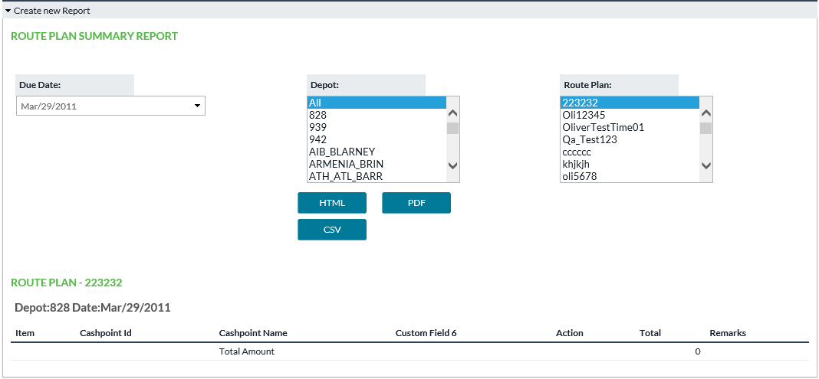

###### Table 36: ROUTE PLAN SUMMARY REPORT FIELD DESCRIPTIONS

|  |  |
| --- | --- |
| Field | Description |
| **Item** | Sequence of stops |
| **Cashpoint Id** | Cashpoint ID of the location being visited |
| **Cashpoint Name** | Cashpoint Name of the location being visited |
| **Custom Field** | Additional info regarding the cashpoint. Meaning determined by user institution. |
| **Action** | Type of order |
| **Denomination - Pieces and Amount** | For each denomination, the number of pieces and amount value to be transported. |
| **Total** | Total amount value |
| **Remarks** | Free field |

Return to: Reports

## ATM RESIDUALS REPORT

This report allows user to view ATM Residual data previously loaded into the system in a CSV file (spreadsheet file).

##### FIGURE 40:ATM RESIDUALS REPORT

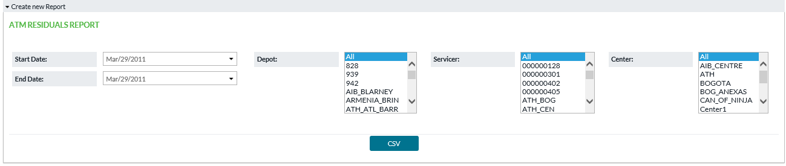

###### Table 37: ATM RESIDUALS REPORT FIELD DESCRIPTIONS

|  |  |
| --- | --- |
| Field | Description |
| **CASHP_ID** | The cashpoint (ATM) from which the residuals originate. |
| **RETURN_DATE** | The date on which the amounts returned from the ATM. |
| **DENOM_ID** | Denomination ID of the cash. |
| **CASSETTE_ID** | Cassette ID, if any. |
| **PREVIOUS_DELIVERY_DATE** | Date of the prior delivery to this ATM. Presumably the residual cash is left over from that delivery. |
| **PREVIOUS_DELIVERY_AMT** | Amount of the prior delivery to this ATM. Presumably the residual cash is left over from that delivery. |
| **WTHDRWLS_SINCE_LAST_DELIVERY** | Count of withdrawals since last delivery. |
| **EXPECTED_RESIDUAL_AMT** | Expected residual amount based on last delivery amount and recorded withdrawals. |
| **ACTUAL_RESIDUAL_AMT** | Residual amount counted after receipt of residual cash. |
| **LINKED_ORDER** | Reference number of the prior delivery to this ATM. |

Return to: Reports

## CONTAINER ASSET REPORT

Purpose of this report is to answer for user two questions: “What containers exist?” (assets list) And “Where are containers now?” (current locations)

##### FIGURE 41:CONTAINER ASSET REPORT

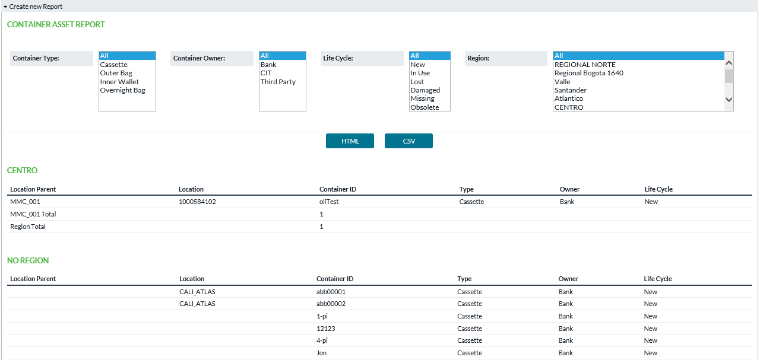

###### Table 38: CONTAINER ASSET REPORT FIELD DESCRIPTIONS

|  |  |
| --- | --- |
| Field | Description |
| **Container Type** | Filter report by type of container |
| **Container Owner** | Filter report by owner of the containers |
| **Life Cycle** | Filter report by life cycle stage of containers |
| **Region** | Filter report by region |
| **Location Parent** | The parent cashpoint of the containers current location, if any. For example, if ATMs are linked under a Branch, then containers located at those ATM show the Branch’s ID in Location Parent field. |
| **Location** | Current location of the container |
| **Container ID** | Identifier of the container |
| **Type** | Container’s type |
| **Owner** | Container’s owner |
| **Life Cycle** | Current life cycle stage of the container |

Return to: Reports

## CONTAINER USE BY LOCATION REPORT

Purpose of this report is to give history of container use at a location: What activities/events occurred here?

##### FIGURE 42:CONTAINER USE BY LOCATION REPORT

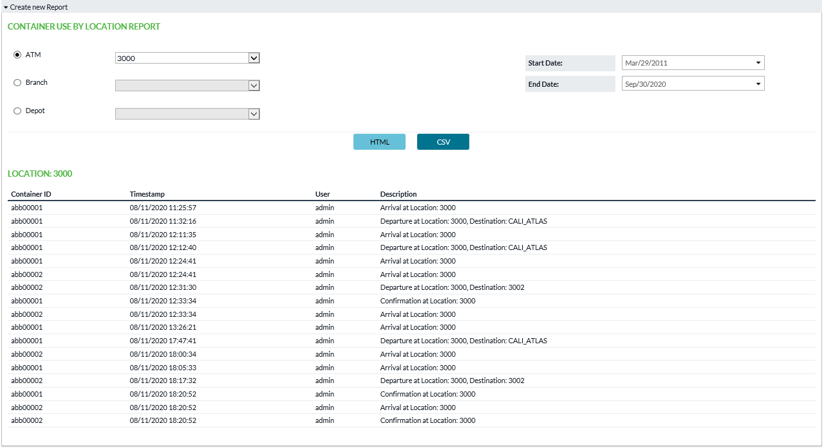

###### Table 39: CONTAINER USE BY LOCATION FIELD DESCRIPTIONS

|  |  |
| --- | --- |
| Field | Description |
| **Location selection** | Choose an ATM, Branch, or Depot to see that location’s use of containers |
| **Start Date/End Date** | Date range which will be included in the report |
| **HTML or CSV buttons** | Open report of the respective type |
| **Container ID** | Identifier of the container |
| **Timestamp** | Date and time when the action was recorded |
| **User** | User who performed the action |
| **Description** | Description of what happened |

Return to: Reports

## VAULT LOAD HISTORY REPORT

Purpose of this report is allow user to see what has been loaded previously via Import Vault History function. That function primarily loads data into OptiVault, but it allows to load in a different format than what OptiVault stores. The records shown in this report are what was loaded before being converted to OptiVault data.

##### FIGURE 43:VAULT LOAD HISTORY REPORT

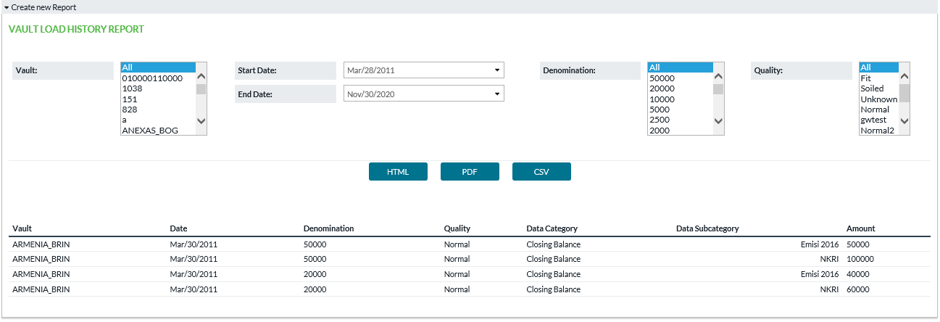

###### Table 40: VAULT LOAD HISTORY REPORT FIELD DESCRIPTIONS

|  |  |
| --- | --- |
| Field | Description |
| **Vault** | Choose vault(s) which will be included in the report. |
| **Start Date/End Date** | Date range which will be included in the report |
| **Denomination** | Denomination(s) which will be included in the report |
| **Quality** | Quality(ies) which will be included in the report |
| **HTML, PDF, or CSV button** | Open report of the respective type |
| **Vault** | Vault to which this history belongs |
| **Date** | Date of this history record |
| **Denomination** | Denomination of the cash |
| **Quality** | Quality of the cash |
| **Data Category** | The label used when loading this particular amount. Categories are configured by your institution and may vary. Categories often tell which field in OptiVault the amount will load into. |
| **Data Subcategory** | Subcategory label used when loading this particular amount. Subcategories are defined by your institution and may vary. Subcategories are not linked to any OptiVault data field – they are used when the users reporting the data desire to break it into components, and the system will sum the subcategories together to find the amount for the associated Category in OptiVault. |
| **Amount** | The amount recorded from Import Vault History. |

Return to: Reports

# SETTINGS

Settings is a gateway menu that provides access to additional screens where administrator users can control Workflow Configuration, System Settings, and User Profiles.

## WORKFLOW CONFIGURATION

Settings→Workflow Configuration assists the Administrative user to control what info is accessible and what actions are allowed to Carrier Web users.

##### Configurations here are structured by each type of workflow (a.k.a. order type). Further controls are available under Settings→Users to map users to the vaults and depots to which they will have access.

##### FIGURE 44:WORKFLOW CONFIGURATION SCREEN

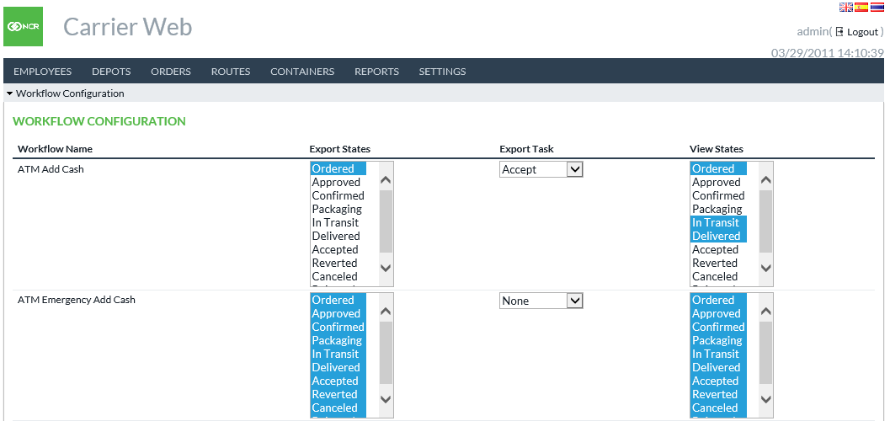

###### Table 41: WORKFLOW CONFIGURATION FIELD DESCRIPTIONS

|  |  |
| --- | --- |
| Field | Description |
| **Workflow Name** | Fixed field showing which Workflow/order type the user is defining |
| **Export States** | Export function performed by CarrierWeb user will include only orders currently in the states selected here. |
| **Export Tasks** | Export function performed by CarrierWeb user will apply this action to the orders. For example, if your institution has defined an “Accept” task that moves orders from “Ordered” to “Accepted” state and “Accept” is selected here, then when a CarrierWeb user exports orders in “Ordered” state those orders will be changed to “Accepted” state. Please note the actions listed here must also be defined in the OptiCash workflow configuration (or OptiVault configuration if Vault type order). |
| **View States** | Orders in the selected states can be viewed in Orders→Search interface (view only). |

Return to: Settings

## SYSTEM SETTINGS

Settings→System Settings allows administrators to determine which currency will be the main or primary currency and which type of order manifest document to use.

##### FIGURE 45:SYSTEM SETTINGS SCREEN

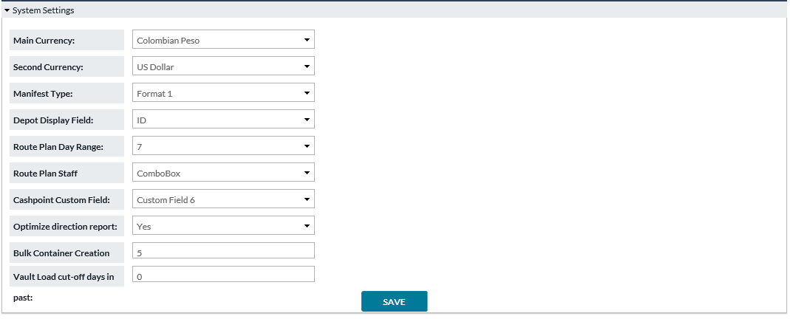

###### Table 42: SYSTEM SETTINGS FIELD DESCRIPTIONS

|  |  |
| --- | --- |
| Field | Description |
| **Main Currency** | The currency selected here will be given priority over other currencies in certain functions that need to sequence one currency before others. |
| **Second Currency** | The currency selected here will be the second currency displayed on pages where 2 currencies are displayed. |
| **Manifest Type** | Refers to the type of manifest document that will be generated for orders. Format0 is default and suitable for most users. Other formats are available to serve specific operations. |
| **Depot Display Field** | Chooses between Depot ID and Depot Name field which will be displayed in CarrierWeb interface. |
| **Route Plan Day Range** | Length of date range used in displaying orders for Route Plan. Checks against the date on which the order was placed and shows those up to today. Example: If this = 3, then orders placed today, yesterday, and day before yesterday are shown. Note: Applies to Route Plans of type “Depot” and not type “Route Definition”. |
| **Route Plan Staff Component Type** | This feature allows a dynamic change in interface functionality. Choices are Combo Box and Input Box. Combo creates a dropdown of available security staff that can then be assigned when users are creating/editing routes. Input Box allows users to key in staff to be included in the route. |
| **Cashpoint Custom Field** | Choose one cashpoint custom field to be included in the Route Plan Summary report (default report format only). Custom fields can be defined any way the client desires. This setting allows 1 piece of information about the cashpoint to be included in the Route Plan Summary. |
| **Optimize Direction Report** | Yes/No. When viewing route plan driving directions, the order of stops in the route may be optimized according to real-time traffic information. If “Yes”, this allows system to override any previous sequence of stops at time of Driving Directions creation. If “No”, then existing sequence is maintained. |
| **Bulk Container Creation Sequence Length** | The number of digits which should be used during bulk creation of new containers. Note: this does not include the prefix – only the numeric suffix. |
| **Vault Load cut-off days in past** | The number of days in past beyond which Import Vault History will not be allowed. |

Return to: Settings

## USERS

Settings→Users allows administrators to define and limit user access to Carrier Web. Users can be granted access to particular Vaults and Depots.

##### FIGURE 46:USER LIST SCREEN

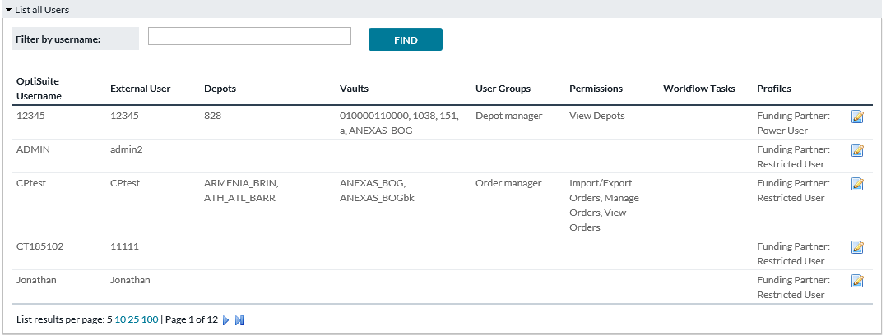

###### Table 43: USERS LIST FIELD DESCRIPTIONS

|  |  |
| --- | --- |
| Field | Description |
| **OptiSuite Username** | Username corresponding with OptiSuite softwares (OptiCash/OptiNet) |
| **External User** | If CarrierWeb is configured to accept user authentication from an outside method, then this will be the user name according to that outside method. |
| **Depots** | Depot entities are configured in OptiCash. The CarrierWeb user will see orders for Branches, ATMs, and Commercials which belong to the Depot(s) selected here. |
| **Vaults** | Vault entities are configured in OptiVault. The CarrierWeb user will see vault orders where Vault(s) selected here are placing the order or are the funding source of the order. Please note that a common configuration involves physical vault locations being listed as both “Depot” and “Vault” with the same name and in that case you would select it in both lists. |
| **User Groups** | Shows what User Group(s)the user belongs to |
| **Permissions** | Shows what OptiVLM screens/functions the user has access to |
| **Workflow Tasks** | Shows what actions/tasks the user can perform in the processing of an Order |
| **Funding Partner (found on Update User Sceen)** | This field allows CW users to be integrated with/limited by the Funding Partner functionality in OptiCash. OD Funding Partner allows Branch users in OC and ON to ship cash to/from other Branch locations. By selecting Restricted User, CW can ship cash between branches that are defined as Funding Partners in OC. By selecting Power User, CW users can ship cash between any two Branches that are supplied by the same Depot. |

Return to: Settings

## UPDATE USER

By clicking on the Update User icon administrators can access the settings of each user and update User assignments. Depot and Vault access can be updated by highlighting additional depots and/or vaults and clicking SAVE.

##### FIGURE 47:UPDATE USER SCREEN

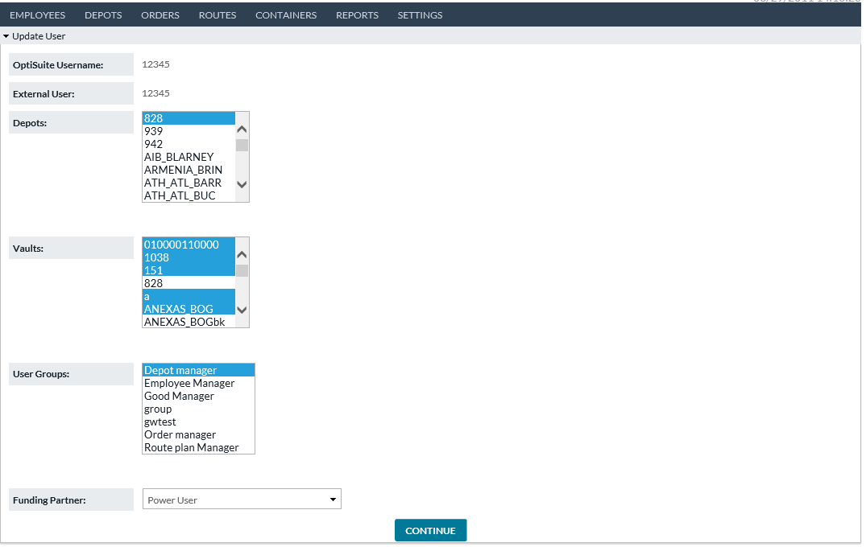

Return to: Settings

## USER GROUPS

User Groups allows administrators to create different classifications of users each defined differently by the types of functionality they can perform or have access to in Carrier Web including Workflow Tasks. This simplifies User administration so that rights and access do not have to be defined for each unique user. Rather, new users can be easily assigned to existing User Groups thus simplifying the process. It also makes keeping track of rights and accesses have been granted.

##### FIGURE 48:USER GROUPS SCREEN

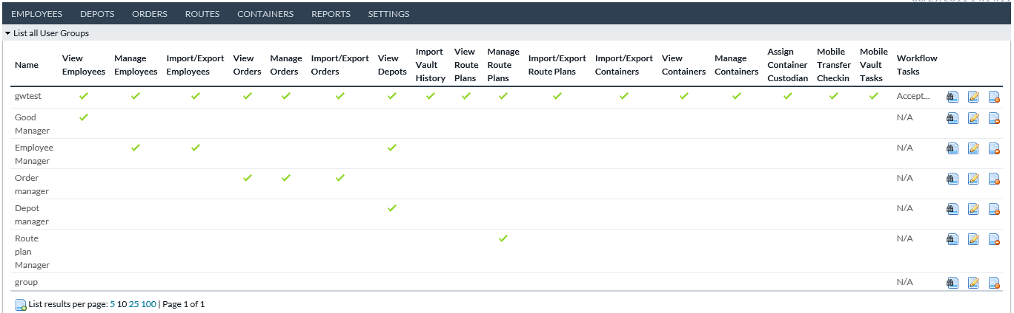

The main User Group screen lists all the existing User Groups and places checkmarks below the Carrier Web functionalities that are granted to the Group. These include Employees (View, Manage, and Import/Export), Orders (View, Manage, and Import/Export), Depots (View and Import History), Route Plans (View, Manage, and Import/Export), Containers (View, Manage, Assign Custodian), and Mobile (Transfer Checkin = Arrival & Departure, Mobile Vault Tasks = Package Order & Container Stock). These functionalities are defined throughout this document.

Order Workflow Tasks granted to the User Group are listed in the Workflow Task column.

Return to: Settings

## SHOW USER GROUP

##### Selecting the View Icon redirects the user to the Show User Group page which is a static single page listing of all the User Group details as currently defined for that group.

##### FIGURE 49:SHOW USER GROUP SCREEN

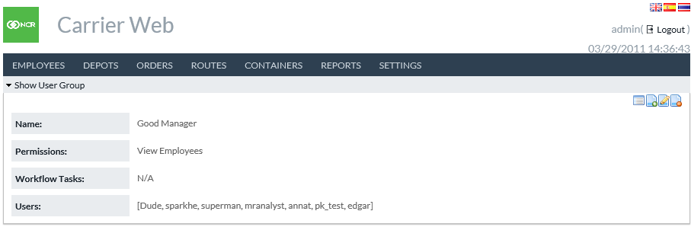

Return to: Settings

## CREATE OR EDIT USER GROUP

The screens where users can create new or edit existing User Groups are identical and can be navigated to via the Update iconfor editing existing User Groups or the Create New icon for creating new User Groups.

When navigating to the Edit Existing User Groups, the already-set Permissions and Workflow tasks will be highlighted.

##### FIGURE 50:CREATE/EDIT USER GROUP SCREEN

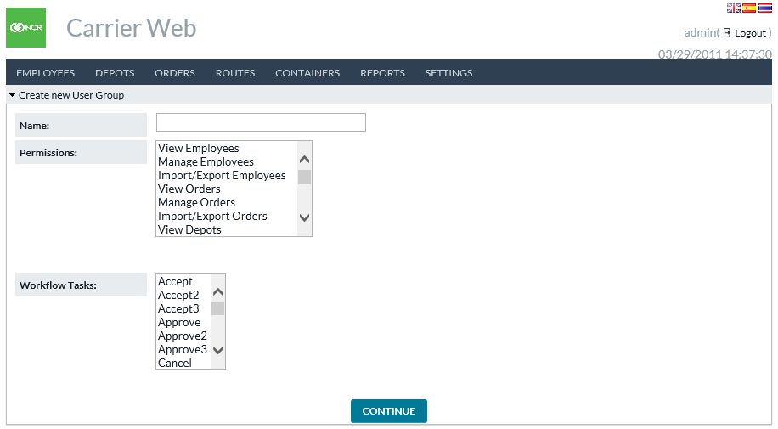

Return to: Settings

## ORDER CUSTOM FIELDS

The Custom Fields page coordinates with Custom Fields that are defined and in use in OptiCash and/or OptiVault. CW users can use the Custom Fields page in Carrier Web to determine which fields will be viewable on the Orders→Orders Workflow and Orders→Search pages in Carrier Web.

##### FIGURE 51:UPDATE CUSTOM FIELDS SCREEN

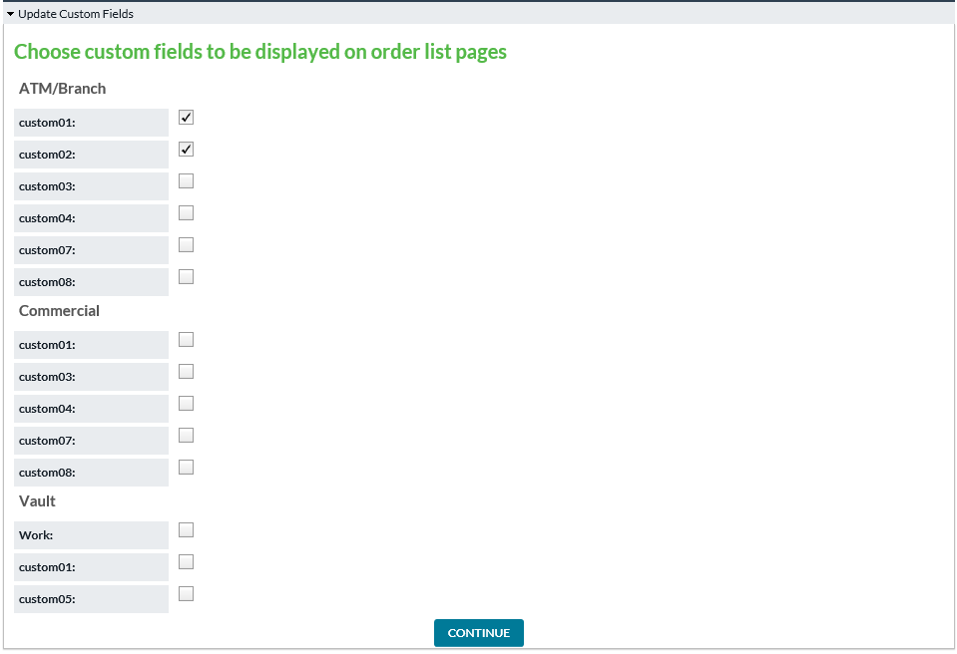

Return to: Settings

## ROUTE FIELD CONFIGURATION

##### Fields in Route Plan may be configured from this page. Route Plan standard fields are always present, but may be set as either Optional or Required. Route Plan custom fields may be further configured, as described in following table.

##### FIGURE 52:ROUTE FIELD CONFIGURATION SCREEN

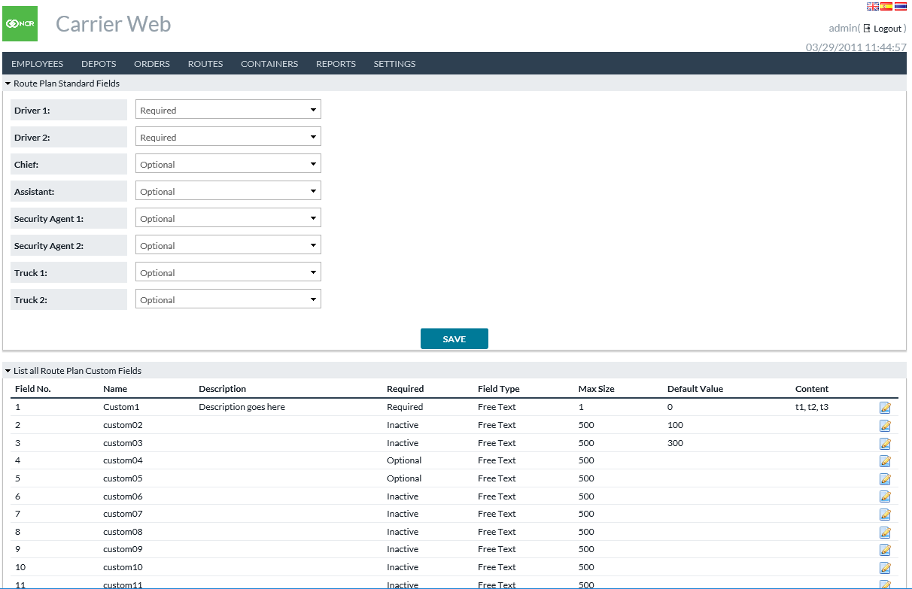

###### Table 44: ROUTE PLAN CUSTOM FIELDS

|  |  |
| --- | --- |
| Field | Description |
| **Field No.** | Field number. 1 to 20. |
| **Name** | Label which will be displayed for this field. |
| **Description** | A longer description or notes about the field. This will NOT be displayed in the Route Plan – just for info here in the configuration. |
| **Required** | Three options: Inactive: This field will not be displayed in the Route Plan. Optional: This field will be displayed, but is not required in order to save the Route Plan.  Required. This field will be displayed and will be required in order to save the Route Plan. |
| **Field Type** | Two options:  Free Text: User is allowed to type in value to be saved in this Route Plan field.  Preset List: User chooses options from a dropdown menu. |
| **Max Size** | Only applicable for Free Text fields. If user types value, then this setting says how far they may go before system prevents additional text. Up to 500 characters is supported. |
| **Default Value** | Value for this field which will be shown when user initially opens Route Plan. Users may override in the Route Plan if desired. |
| **Content** | Only applicable for Preset List fields. Options to show in dropdown menu written as a comma-separated list. For example “t1,t2,t3” results in options t1, t2, and t3 appearing in dropdown menu. |

Return to: Settings

## ROUTE PLAN WORKFLOW

##### Route Plans may follow a configurable workflow: from one status to another, with pre-defined transitions available at each point. This page does the configuration. Route Plan Workflows: In the upper section, you may define the transitions allowed for a Route Plan. Each is identified by a pair of statuses – Begin and End. Note that the available statuses may be modified by your institution during application install or later configuration, up to 20 statuses total.

##### Route Order Updates: When a Route Plan changes status, the system may attempt to update the included orders. The lower section of page here configures if and how that will occur. Note: If an order update is attempted through the Route Plan, that action must follow the rules of the Order Workflow settings established in OptiCash and/or OptiVault. If Route Plan attempts to do an ordering task that is not allowed, then the order will simply not be updated.

##### FIGURE 53:ROUTE PLAN WORKFLOW SCREEN

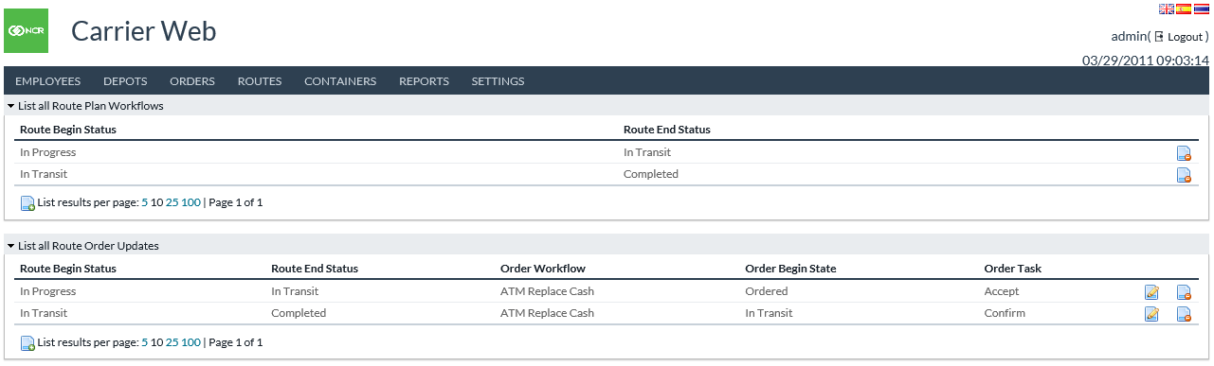

###### Table 45: ROUTE PLAN WORKFLOW FIELDS

|  |  |
| --- | --- |
| Field | Description |
| **Route Begin Status** | This configuration will be in effect when the Route Plan begins in this status. |
| **Route End Status** | This status is where the Route Plan will end its transition. |
| **Order Workflow** | Which type of orders in the Route Plan will be included for this action. |
| **Order Begin State** | Orders in the Route Plan currently in this state will be included for this action. |
| **Order Task** | The action (Task) which will be applied to the orders in Route Plan fitting the preceding criteria. |

Return to: Settings

## VAULT LOAD CONFIGURATION

##### See outside document Input/Output Formats Guide for detailed specification of the input file formats used in Import Vault History function. That will refer to Categories and Subcategories used in the import process. Definition of the Categories and Subcategories is done here in Vault Load Configuration page. Categories refer to types of data that may be input during Import Vault History. The Category is effectively a label which will appear in import file and you may map that label to its ultimate destination in an OptiVault data field. If more than one Category is mapped to same OptiVault field, then the imported amounts are summed together. Subcategories refer to optional additional detail which may be provided during Import Vault History, but does not map to OptiVault fields directly. Subcategories will only appear under a defined Category and any amounts imported this way will be summed up to the Category level when stored in OptiVault.

##### FIGURE 54:VAULT LOAD CONFIGURATION SCREEN

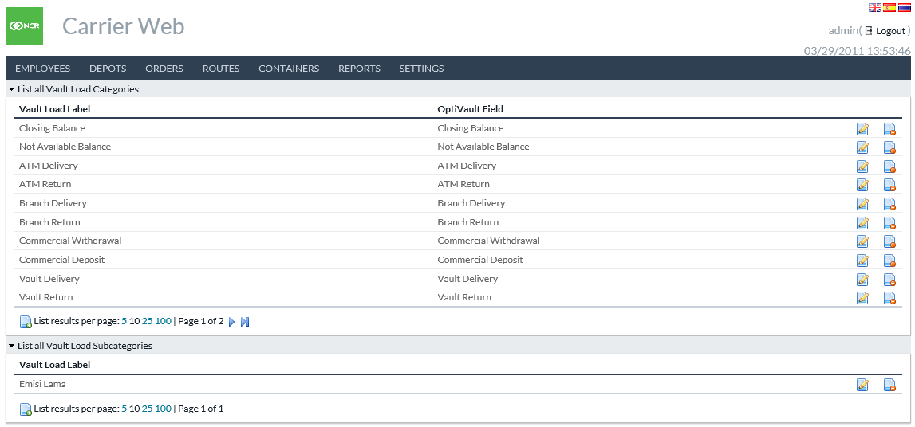

###### Table 46: VAULT LOAD CONFIGURATION FIELDS

|  |  |
| --- | --- |
| Field | Description |
| **Vault Load Label (Category)** | The text as it will appear in input file of Import Vault History function. |
| **OptiVault Field (Category)** | The destination data field in OptiVault for data under this Category. |
| **Vault Load Label (Subcategory)** | The text as it will appear in input file of Import Vault History function. |

Return to: Settings

## 

## NOTIFICATION HISTORY

##### When background processes finish and provide status information, that will be listed on the Notification History page. Links to download output may be available in some cases.

##### FIGURE 55:NOTIFICATION HISTORY SCREEN

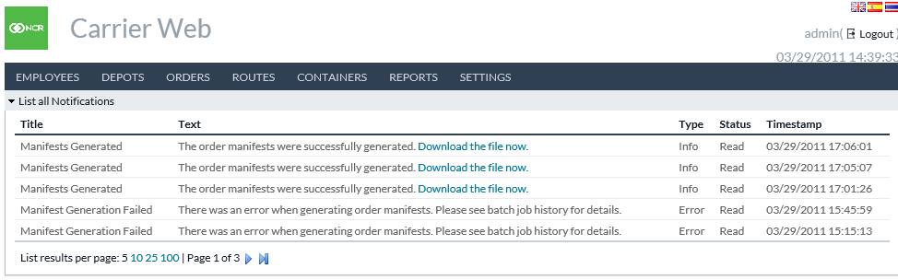

Return to: Settings

# Mobile CarrierWeb

CarrierWeb offers a mobile interface for accomplishing certain tasks. These are related to day-to-day activities transporting cash and managing the container inventory at various locations. Mobile interface appears when accessing the usual OptiVLM-CarrierWeb URL through a mobile device and users are given the following home menu to begin.

##### FIGURE 56:MOBILE HOME MENU SCREEN

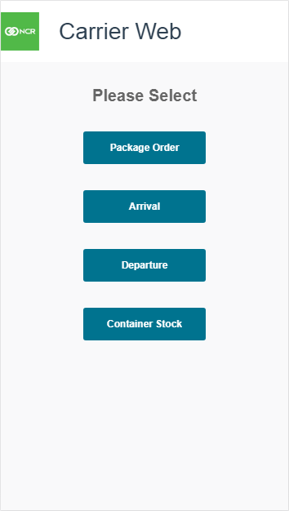

## PACKAGE ORDER

##### Package Order is intended for a cash transfer prior to it leaving the funding source. This function will associate an Order with Containers, which in turn allows both tracking of the containers and later alerts to carrier personnel if they attempt to deliver too many or too few containers with an order.

##### FIGURE 57:PACKAGE ORDER SCAN SCREEN

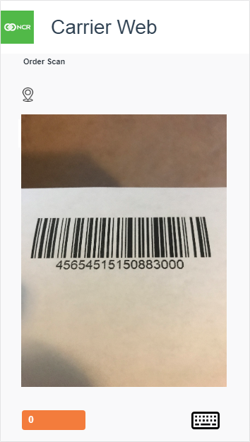

###### Table 47: PACKAGE ORDER SCAN SCREEN ELEMENTS

|  |  |
| --- | --- |
| Field | Description |
| **Order or Container Scan** | Top left corner of screen. This text indicates mode. Initially user will be asked to scan or type an Order ID. Afterward, this text switches to Container Scan and user may then scan Containers to associate with the order. |
| **Location Indicator** | Top left corner, underneath Order or Container Scan indicator. This displays the location derived from the order. |
| **Scan Window** | Uses the device camera for barcode scanning. Simply point the camera at a barcode of the order or container (as indicated by the scan mode above). |
| **Progress Indicator** | Orange button in lower left corner of screen. This displays a count of containers entered for this order. Tap this button when finished entering containers to continue to next screen. |
| **Keyboard Entry** | Keyboard icon in lower right corner of screen. Tap this to type order or container IDs. Optional. This is typically only used if there is some malfunction with the barcode scan. |

##### FIGURE 58:PACKAGE ORDER ENTRY REVIEW SCREEN

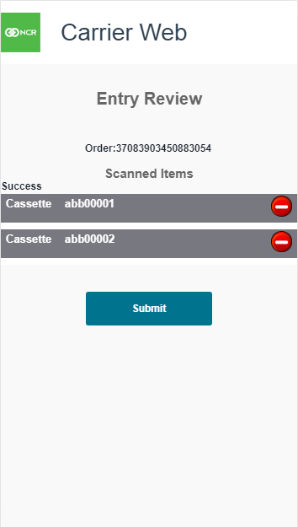

###### Table 48: PACKAGE ORDER ENTRY REVIEW SCREEN ELEMENTS

|  |  |
| --- | --- |
| Field | Description |
| **Order** | Order ID of the order being packaged. |
| **Scanned Items** | List of containers to be associated with this order. User may tap the  icon to remove a scanned item. |
| **Submit Button** | Finishes the order packaging. Listed containers are associated with the indicated order, and user is returned to the mobile home menu. |

Return to: Mobile CarrierWeb

## ARRIVAL

##### Arrival function, like the name says, is intended for use when a transfer arrives at the destination. This indicates to the system that the cash and containers have arrived. Users are expected to scan the containers at this point.

##### FIGURE 59:ARRIVAL SCAN SCREEN

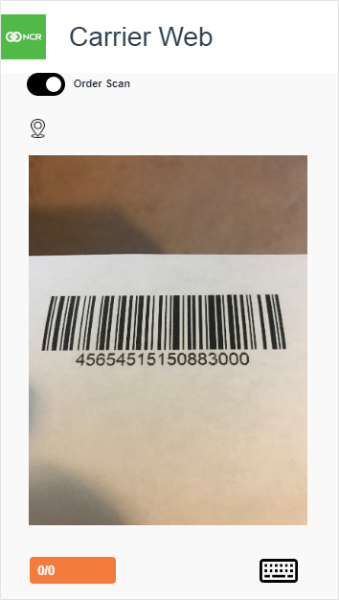

###### Table 49: ARRIVAL SCAN SCREEN ELEMENTS

|  |  |
| --- | --- |
| Field | Description |
| **Order or Container Scan** | Top left corner of screen. This toggle indicates mode. User may scan an order, or containers, or both. |
| **Location Indicator** | Top left corner, underneath Order or Container Scan indicator. This displays the location derived from the order. If incorrect, user may change it on the following screen. |
| **Scan Window** | Uses the device camera for barcode scanning. Simply point the camera at a barcode of the order or container (as indicated by the scan mode above). |
| **Progress Indicator** | Orange button in lower left corner of screen. First number is count of containers scanned, second number is the expected number for this order (if applicable). For example, if scan an order first and that order was previously associated with 4 containers, then this would display “0/4”, then “1/4” after scanning 1 container, etc. Tap this button when finished scanning to continue to next screen. |
| **Keyboard Entry** | Keyboard icon in lower right corner of screen. Tap this to type order or container IDs. Optional. This is typically only used if there is some malfunction with the barcode scan. |

##### FIGURE 60:ARRIVAL ENTRY REVIEW SCREEN

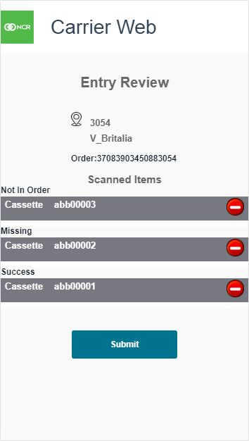

###### Table 50: ARRIVAL ENTRY REVIEW SCREEN ELEMENTS

|  |  |
| --- | --- |
| Field | Description |
| **Location** | Location where the order and/or containers are arriving. Tap to change location if necessary. |
| **Order** | Order ID of the arriving order, if selected previously. |
| **Scanned Items** | List of scanned containers. User may tap the  icon to remove a scanned item. Comes in 3 possible status: **Not In Order**: The scanned container was not expected to be part of this order. User should consider this an alert of possible mistake. If submitted as is, this container will be moved to this location.  **Missing**: A container was expected to be with this order, but was not scanned. User should consider this an alert of possible mistake. If submitted as is, this container will be marked missing.  **Success**: This container was scanned as expected. |
| **Submit Button** | Finishes the Arrival function. Order and/or containers are updated in the system as having arrived. |

Return to: Mobile CarrierWeb

## DEPARTURE

##### Departure function, like the name says, is intended for use when an transfer leaves its source. This indicates to the system that the cash and containers have departed. Users are expected to scan the containers at this point.

##### FIGURE 61:DEPARTURE SCAN SCREEN



###### Table 51: DEPARTURE SCAN SCREEN ELEMENTS

|  |  |
| --- | --- |
| Field | Description |
| **Order or Container Scan** | Top left corner of screen. This toggle indicates mode. User may scan an order, or containers, or both. |
| **Location Indicator** | Top left corner, underneath Order or Container Scan indicator. This displays the location derived from the order. If incorrect, user may change it on the following screen. |
| **Scan Window** | Uses the device camera for barcode scanning. Simply point the camera at a barcode of the order or container (as indicated by the scan mode above). |
| **Progress Indicator** | Orange button in lower left corner of screen. First number is count of containers scanned, second number is the expected number for this order (if applicable). For example, if scan an order first and that order was previously associated with 4 containers, then this would display “0/4”, then “1/4” after scanning 1 container, etc. Tap this button when finished scanning to continue to next screen. |
| **Keyboard Entry** | Keyboard icon in lower right corner of screen. Tap this to type order or container IDs. Optional. This is typically only used if there is some malfunction with the barcode scan. |

##### FIGURE 62:DEPARTURE ENTRY REVIEW SCREEN

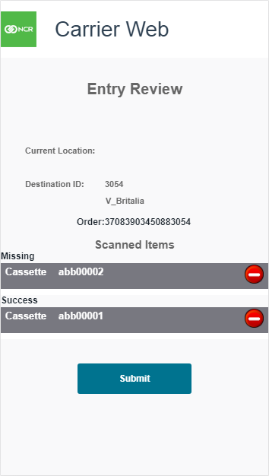

###### Table 52: DEPARTURE ENTRY REVIEW SCREEN ELEMENTS

|  |  |
| --- | --- |
| Field | Description |
| **Current Location** | Location where the order and/or containers are departing. Tap to change location if necessary. |
| **Destination ID** | Destination location for the order and/or containers. Tap to change location if necessary. |
| **Order** | Order ID of the departing order, if selected previously. |
| **Scanned Items** | List of scanned containers. User may tap the  icon to remove a scanned item. Comes in 3 possible status: **Not In Order**: The scanned container was not expected to be part of this order. User should consider this an alert of possible mistake. If submitted as is, this container will be moved to this location.  **Missing**: A container was expected to be with this order, but was not scanned. User should consider this an alert of possible mistake. If submitted as is, this container will be marked missing.  **Success**: This container was scanned as expected. |
| **Submit Button** | Finishes the Departure function. Order and/or containers are updated in the system as having departed. |

Return to: Mobile CarrierWeb

## CONTAINER STOCK

##### Container Stock function is for inventory or stock taking activities at a particular location – often a cash center or container warehouse. This will update the system by confirming the current location of containers.

##### FIGURE 63:CONTAINER STOCK SCAN SCREEN

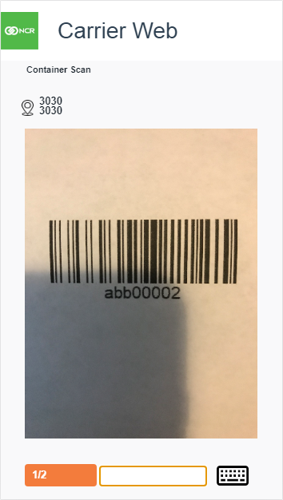

###### Table 53: CONTAINER STOCK SCAN SCREEN ELEMENTS

|  |  |
| --- | --- |
| Field | Description |
| **Container Scan** | Top left corner of screen. Indicates that you are scanning containers here. |
| **Location Indicator** | Top left corner, underneath Container Scan indicator. This displays the location derived from a container. If incorrect, user may change it on the following screen. |
| **Scan Window** | Uses the device camera for barcode scanning. Simply point the camera at a barcode of the order or container (as indicated by the scan mode above). |
| **Progress Indicator** | Orange button in lower left corner of screen. First number is count of containers scanned, second number is the expected number at this location. Tap this button when finished scanning to continue to next screen. |
| **Keyboard Entry** | Keyboard icon in lower right corner of screen. Tap this to type container IDs. Optional. This is typically only used if there is some malfunction with the barcode scan. |

##### FIGURE 64:CONTAINER STOCK ENTRY REVIEW SCREEN

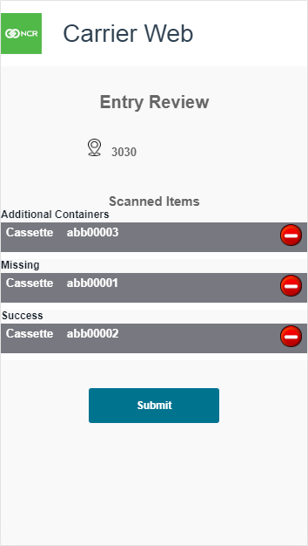

###### Table 54: CONTAINER STOCK ENTRY REVIEW SCREEN ELEMENTS

|  |  |
| --- | --- |
| Field | Description |
| **Location** | Location for this inventory. |
| **Scanned Items** | List of scanned containers. User may tap the  icon to remove a scanned item. Comes in 3 possible status: **Additional Containers**: The scanned container was not expected to be at this location. If submitted as is, this container will be moved to this location.  **Missing**: A container was expected to be at this location, but was not scanned. If submitted as is, this container will be marked missing.  **Success**: This container was scanned as expected. |
| **Submit Button** | Finishes the Container Stock function. Containers are confirmed to be at this location, or missing, respectively. |

Return to: Mobile CarrierWeb

# APPENDIX A: OPTITRANSPORT

OptiTransport is an additional licensed functionality that facilitates optimization across an entire network or portion of it. It also facilitates optimization of delivery routing based upon physical location and the shortest and most efficient path to service all cashpoints on a route.

The portion of functionality concerned with network optimization of cashpoint delivery days is handled by NCR’s OptiCash product beginning with OptiCash 9.5 build 1257 and information regarding those features can be found in the OptiCash User Guide.

CarrierWeb is concerned with the route planning portion of OptiTransport. Standard CarrierWeb functionality permits the association of cashpoint deliveries and returns with a specific Depot. Within CarrierWeb, users may define delivery vehicles or “trucks” which are associated with specific Depots. Cashpoint deliveries and returns are assigned to a truck and services are then performed.

OptiTransport facilitates the association of cashpoint deliveries and returns with unique routes which can then be assigned to a truck. Using the physical location of the starting point and that of each cashpoint associated with the route, OptiTransport can determine the shortest route to accomplish the assigned deliveries and returns. Users can also manually define or edit routes if necessary.

## SHORTEST PATH CALCULATION PANEL

##### Users may utilize the Route Travel Plans Optimization (RTPO) available via CarrierWeb. Users can associate Deliveries and Returns with a unique route. Once the relevant Deliveries and Returns are selected, Users can click on the “Calculate Shortest Path” selector which allows CarrierWeb to determine the distance-optimal route for servicing the associated orders.

##### FIGURE 65:SHORTEST PATH CALCULATION PANEL



###### Table 55: SHORTEST PATH CALCULATION PANEL FIELD DESCRIPTIONS

|  |  |
| --- | --- |
| Field | Description |
| **Show or Hide Details** | Opens and Closes the Shortest Path Calculation Panel |
| **Calculate Shortest Path** | Referencing each “Assigned Order” on the Update Route Plan screen, OptiTransport will calculate the shortest route required to service each order. |
| **Rank** | Automated number assigned to each Assigned Order according to their place of occurrence for the time which they will be serviced |
| **From** | Originating location |
| **To** | Destination location |
| **Order Type** | ATM Replace Cash, Branch Delivery, Branch Return, etc. |
| **Distance** | Physical distance (km) between “From” and “To” locations |
| **Order Reference** | Unique ID assigned to the order |

[Brand] [Product], [DocTitle]

Back page info (e.g. DocNumber, DocNumberIssue)

[Date (Month Year)]

NCR welcomes your feedback on this document. Your comments can be of great value in helping us improve our information products. Please contact us using the following address:

[email: xxxx@yyyy]

[web: <https://xxx.xxx.xxx>]